**AIRLINE DATABASE MANAGEMENT**

**Final Project for Introduction of SQL By SHUBHAM KHANDAGALE**

1. **Description**

The Airline Database Management System project aims to develop a comprehensive database system to manage various aspects of an airline company. The system will facilitate the storage, retrieval, and manipulation of data related to airlines, flights, employees, passengers, bookings, payments, and more. It will provide an efficient and reliable platform for managing day-to-day operations, improving customer service, and streamlining administrative tasks within the airline industry.

**Key Features and Functionality:**

* Airline Management: The system will allow the airline company to maintain a centralized database of airlines, including details such as airline name, country, headquarters, established year, website, and contact information.
* Flight Management: The system will enable the management of flight information, including flight numbers, names, destinations, sources, distances, departure dates and times, arrival times, and available seat capacity.
* Employee Management: The system will store employee information, including employee names, positions, salaries, and their association with specific airlines. It will assist in managing employee records and monitoring their assignments and responsibilities.
* Baggage Management: The system will manage baggage-related information, including baggage IDs, weights, passenger associations, and flight associations. It will help in tracking and managing passenger baggage throughout their journey.
* Payment Processing: The system will handle payment transactions, including payment modes (credit card, cash, etc.), card details, amounts, and payment statuses. It will securely process payments, validate card information, and generate payment transaction IDs.

**This Database contains 10 tables:**

1. Airline
2. Employee
3. Aircraft
4. Aircraft_employee
5. User
6. Flight
7. Baggage
8. Ticket
9. Payment
10. BoardingPass
11. **ER-Diagram for Airline Database Management:**

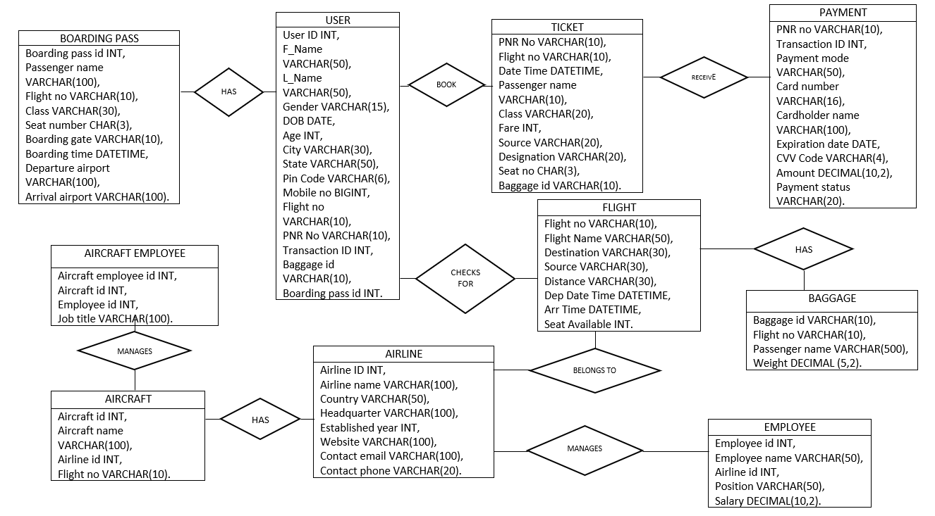

1. **Table Descriptions:**

1. Airline

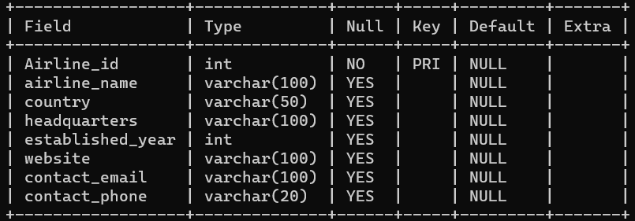

1. Employee

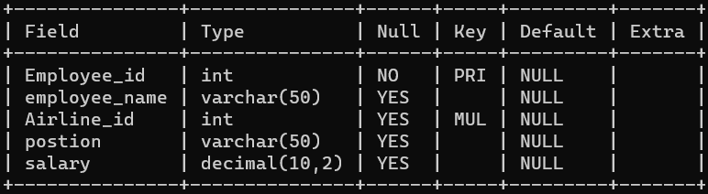

1. Aircraft

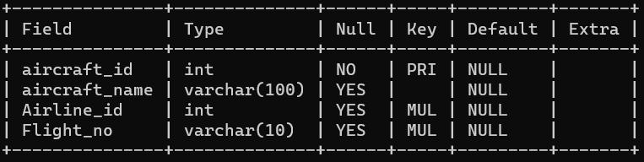

1. Aircraft_employee

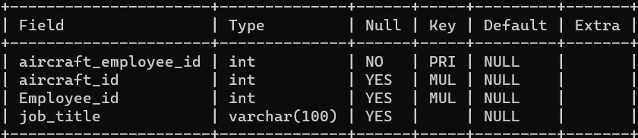

1. User

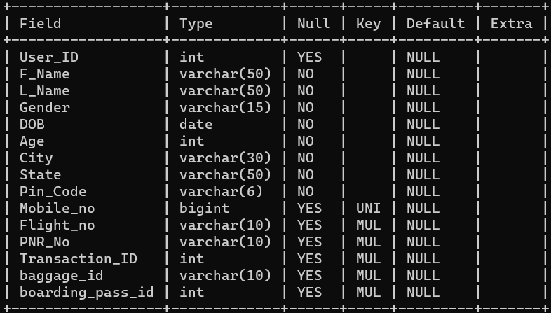

1. Flight

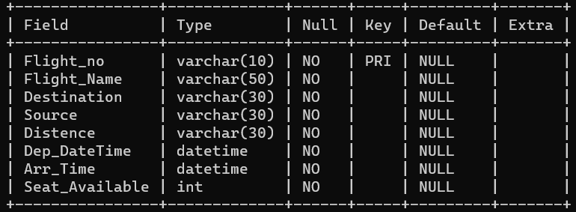

1. Baggage

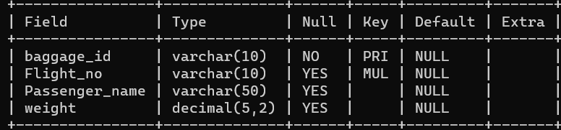

1. Ticket

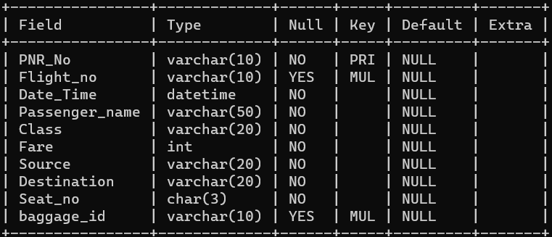

1. Payment

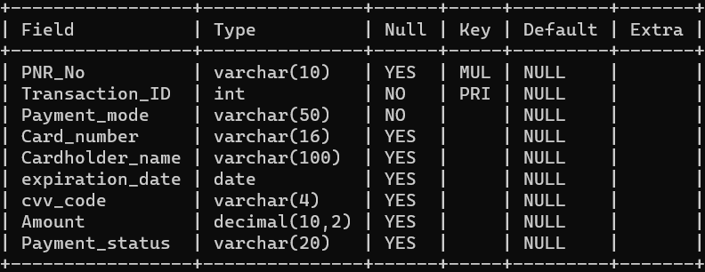

1. Boardingpass

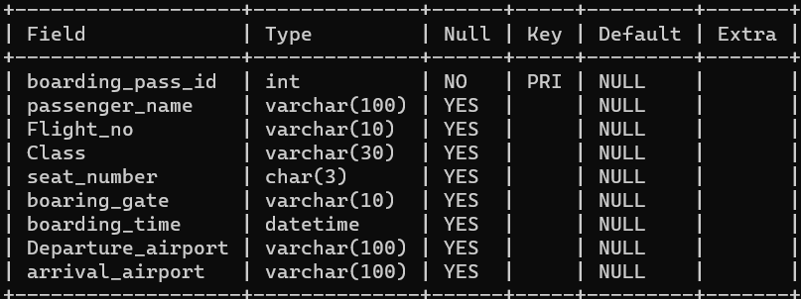

\

1. **Commands:**

* **Create Database:**

create database Air_ITV;

* **Use Database:**

use Air_ITV;

* **Create table Airline:**

create table Airline(Airline_id int primary key,airline_name varchar(100),country varchar(50),headquarters varchar(100),established_year int,website varchar(100),contact_email varchar(100),contact_phone varchar(20));

* **Create table Employee:**

create table Employee(Employee_id int primary key,employee_name varchar(50),Airline_id int,foreign key(Airline_id) references Airline(Airline_id),postion varchar(50),salary decimal(10,2));

* **Create table Aircraft:**

create table Aircraft(aircraft_id int primary key,aircraft_name varchar(100),Airline_id int,Flight_no varchar(10),foreign key(Airline_id) references Airline(Airline_id),foreign key(Flight_no) references Flight(Flight_no));

* **Create table Aircarft_employee:**

create table Aircraft_employee(aircraft_employee_id int primary key,aircraft_id int,Employee_id int,job_title varchar(100),foreign key(aircraft_id) references Aircraft(aircraft_id),foreign key(Employee_id) references Employee(Employee_id));

* **Create table Flight:**

create table Flight(Flight_no varchar(10) primary key,Flight_Name varchar(50) not null,Destination varchar(30) not null,Source varchar(30) not null,Distence varchar(30) not null,Dep_DateTime datetime not null,Arr_Time datetime not null,Seat_Available int not null);

* **Create table Ticket:**

create table Ticket(PNR_No varchar(10) primary key,Flight_no varchar(10),foreign key(Flight_no) references Flight(Flight_no),Date_Time datetime not null,Passenger_name varchar(50) not null,Class varchar(20) not null,Fare int not null,Source varchar(20) not null,Destination varchar(20) not null,Seat_no char(3) not null,baggage_id varchar(10),foreign key(baggage_id) references Baggage(baggage_id));

* **Create table Payment:**

create table Payment(PNR_No varchar(10),foreign key(PNR_NO) references Ticket(PNR_No),Transaction_ID int primary key,Payment_mode varchar(50) not null,Card_number varchar(16),Cardholder_name varchar(100),expiration_date date,cvv_code varchar(4),Amount decimal(10,2),Payment_status varchar(20));

* **Create table baggage:**

create table Baggage(baggage_id varchar(10) primary key,Flight_no varchar(10),Passenger_name varchar(50),weight decimal(5,2),foreign key(Flight_no) references Flight(Flight_no));

* **Create table boardingpass:**

create table BoardingPass(boarding_pass_id int primary key,passenger_name varchar(100),Flight_no varchar(10),Class varchar(30),seat_number char(3),boaring_gate varchar(10),boarding_time datetime,Departure_airport varchar(100),arrival_airport varchar(100));

* **Create table User:**

create table User(User_ID int,F_Name varchar(50) not null,L_Name varchar(50) not null,Gender varchar(15) not null,DOB date not null,Age int not null,City varchar(30) not null,State varchar(50) not null,Pin_Code varchar(6) not null,Mobile_no bigint unique,Flight_no varchar(10),PNR_No varchar(10),Transaction_ID int,baggage_id varchar(10),boarding_pass_id int,foreign key(Flight_no) references Flight(Flight_no),foreign key(PNR_No) references Ticket(PNR_No),foreign key(Transaction_ID) references Payment(Transaction_ID),foreign key(baggage_id) references Baggage(baggage_id),foreign key(boarding_pass_id) references BoardingPass(boarding_pass_id));

* Insert values into the Airline:
* INSERT INTO Airline (Airline_id, airline_name, country, headquarters, established_year, website, contact_email, contact_phone)
* VALUES
* (1, 'Air ITV', 'India', 'Mumbai', '1932', 'AirITV.in', 'info@AirITV.in', '+91-11-24624074'),
* (2, 'IndiGo', 'India', 'Gurugram', '2006', 'goindigo.in', 'corporate@goindigo.in', '+91-124-6613838'),
* (3, 'SpiceJet', 'India', 'Gurugram', '2005', 'spicejet.com', 'custrelations@spicejet.com', '+91-9871803333'),
* (4, 'Vistara', 'India', 'Gurugram', '2014', 'airvistara.com', 'vistaracustomercare@airvistara.com', '+91-9289228888');
* Insert values into the Employee:

INSERT INTO Employee (Employee_id, employee_name, Airline_id, postion, salary)

VALUES

(1, 'Sahil bhore', 1, 'Pilot', 90000.00),

(2, 'Sanket Daeima', 3, 'Flight Attendant', 35000.00),

(3, 'Rahul Sharma', 4, 'Ground Staff', 25000.00),

(4, 'Neha Patel', 1, 'Customer Service', 30000.00),

(5, 'Prashant Dumbare', 1, 'Pilot', 75000.00),

(6, 'Aarav Patel', 3, 'Aircraft Mechanic', 50000.00),

(7, 'Riya Sharma', 2, 'flight Attendant', 40000.00),

(8, 'Advait Singh', 4, 'Air Traffic Controller', 80000.00),

(9, 'Anika Verma', 2, 'Pilot', 90000.00),

(10, 'Arjun Kapoor', 1, 'Baggage Handler/Ramp Agent', 28000.00),

(11, 'Devansh Chaudhary', 4, 'Pilot', 90000.00),

(12, 'Ishaan Sharma', 4, 'Airport Operations Manager', 90000.00),

(13, 'Kiara Reddy', 1, 'Flight Attendant', 40000.00),

(14, 'Reyansh Desai', 3, 'Aircraft Maintenance Manager', 100000.00),

(15, 'Siya Mehta', 4, 'Flight Attendant', 40000.00),

(16, 'Vivaan Malhotra', 2, 'Ground Services Manager', 100000.00),

(17, 'Yashvi Patel', 3, 'Flight Attendant', 90000.00),

(18, 'Aanya Jain', 1, 'Cabin Crew Manager', 75000.00),

(19, 'Aryan Bhatia', 4, 'Customer Service Agent', 30000.00),

(20, 'Diya Khanna', 2, 'Flight Attendant', 40000.00),

(21, 'Diya Khanna', 3, 'Customer Service Agent', 30000.00),

(22, 'Neel Joshi', 1, 'Cabin Crew Manager', 75000.00),

(23, 'Prisha Shah', 2, 'Cabin Crew Manager', 75000.00),

(24, 'Reyaan Choudhury', 4, 'Airport Operations Manager', 110000.00),

(25, 'Shivangi Kumar', 3, 'Flight Attendant', 40000.00),

(26, 'Tanishka Agrawal', 1, 'Flight Attendant', 40000.00),

(27, 'Virat Singhania', 2, 'Aircraft Maintenance Manager', 100000.00),

(28, 'Zara Srinivasan', 3, 'Cabin Crew Manager', 75000.00),

(29, 'Aadi Kapoor', 4, 'Pilot', 90000.00),

(30, 'Ananya Das', 4, 'Flight Attendant', 40000.00),

(31, 'Ayaan Khurana', 1, 'Airport Operations Manager', 110000.00),

(32, 'Ishani Mittal', 2, 'Flight Attendant', 40000.00),

(33, 'Krish Tiwari', 3, 'Pilot', 90000.00),

(34, 'Myra Pandey', 4, 'Aircraft Mechanic', 50000.00),

(35, 'Parth Mehta', 2, 'Pilot', 90000.00),

(36, 'Riddhi Doshi', 1, 'Flight Attendant', 40000.00),

(37, 'Saanvi Sharma', 3, 'Baggage Handler', 28000.00),

(38, 'Shaurya Varma', 4, 'Ground Services Manager', 90000.00),

(39, 'Aradhya Chawla', 2, 'Customer Service Agent', 30000.00),

(40, 'Darsh Shah', 1, 'Airport Operations Manager', 110000.00),

(41, 'Hridya Nair', 3, 'Air Traffic Controller', 80000.00),

(42, 'Ishita Agarwal', 4, 'Flight Attendant', 40000.00),

(43, 'Jai Patel', 4, 'Pilot', 90000.00),

(44, 'Kiaan Iyer', 2, 'Aircraft Maintenance Manager', 100000.00),

(45, 'Nandini Krishnan', 1, 'Cabin Crew Manager', 75000.00),

(46, 'Parv Sharma', 3, 'Pilot', 90000.00),

(47, 'Reyanshi Menon', 4, 'Flight Attendant', 40000.00),

(48, 'Shanaya Malhotra', 2, 'Pilot', 90000.00),

(49, 'Sia Raghavan', 1, 'Baggage Handler', 28000.00),

(50, 'Anaya Singhania', 1, 'Flight Attendant', 40000.00),

(51, 'Arya Dutta', 3, 'Ground Services Manager', 90000.00),

(52, 'Divit Chandra', 1, 'Pilot', 90000.00),

(53, 'Ishani Nair', 2, 'Cabin Crew Manager', 75000.00),

(54, 'Kiaan Patel', 4, 'Air Traffic Controller', 80000.00),

(55, 'Myra Joshi', 1, 'Customer Service Agent', 30000.00),

(56, 'Pranav Sharma', 2, 'Baggage Handler', 28000.00),

(57, 'Reva Deshmukh', 3, 'Customer Service Agent', 30000.00),

(58, 'Rishaan Gupta', 4, 'Baggage Handler', 28000.00),

(59, 'Shivani Verma', 1, 'Customer Service Agent', 30000.00),

(60, 'Siya Chaudhary', 2, 'Customer Service Agent', 30000.00),

(61, 'Yuvika Kapoor', 3, 'Cabin Crew Manager', 75000.00),

(62, 'Aaradhya Reddy', 1, 'Baggage Handler', 25000.00),

(63, 'Ananya Iyer', 2, 'Customer Service Agent', 30000.00),

(64, 'Arnav Mehra', 3, 'Baggage Handler', 28000.00),

(65, 'Diyaan Pandey', 4, 'Baggage Handler', 28000.00),

(66, 'Ishita Gupta', 1, 'Cabin Crew Manager', 75000.00),

(67, 'Harsh Shah', 2, 'Baggage Handler', 28000.00),

(68, 'Kiyaan Krishnan', 3, 'Aircraft Mechanic', 50000.00),

(69, 'Mannat Jain', 4, 'Customer Service Agent', 30000.00),

(70, 'Nysa Tiwari', 1, 'Flight Attendant', 40000.00),

(71, 'Parthvi Kapoor', 2, 'Pilot', 90000.00),

(72, 'Rehaan Menon', 3, 'Cabin Crew Manager', 75000.00),

(73, 'Riyaan Das', 4, 'Air Traffic Controller', 80000.00),

(74, 'Shaanvi Bajaj', 1, 'Pilot', 90000.00),

(75, 'Advik Chawla', 2, 'Airport Operations Manager', 110000.00),

(76, 'Anushka Patel', 3, 'Flight Attendant', 40000.00),

(77, 'Arush Sharma', 4, 'Pilot', 90000.00),

(78, 'Diya Patel', 1, 'Customer Service Agent', 30000.00),

(79, 'Kiyan Gupta', 2, 'Aircraft Maintenance Manager', 100000.00),

(80, 'Mannan Verma', 3, 'Pilot', 90000.00),

(81, 'Ethan Walker', 4, 'Customer Service Agent', 30000.00),

(82, 'Olivia Bennett', 1, 'Flight Attendant', 40000.00),

(83, 'Liam Foster', 2, 'Flight Attendant', 40000.00),

(84, 'Ava Campbell', 3, 'Flight Attendant', 40000.00),

(85, 'Sophia Murphy', 4, 'Flight Attendant', 40000.00),

(86, 'Noah Gray', 1, 'Air Traffic Controller', 80000.00),

(87, 'Lucas Turner', 2, 'Ground Services Manager', 90000.00),

(88, 'Mia Mitchell', 4, 'Cabin Crew Manager', 75000.00),

(89, 'Isabella Ross', 3, 'Pilot', 90000.00),

(90, 'Benjami Wright', 1, 'Customer Service Agent', 30000.00),

(91, 'Henry Cox', 2, 'Airport Operations Manager', 110000.00),

(92, 'Harper Evans', 3, 'Ramp Agent', 28000.00),

(93, 'Samuel Hughes', 4, 'Ramp Agent', 28000.00),

(94, 'Amelia Reed', 1, 'Pilot', 90000.00),

(95, 'Alexander Morgan', 2, 'Ramp Agent', 28000.00),

(96, 'Charlotte Peterson', 3, 'Ramp Agent', 28000.00),

(97, 'Daniel Stewart', 4, 'Ramp Agent', 28000.00),

(98, 'Emily Phillips', 1, 'Pilot', 90000.00),

(99, 'Matthew Jenkins', 2, 'Pilot', 90000.00),

(100, 'Abigail Taylor', 4, 'Ramp Agent', 28000.00);

* Insert values into the aircraft:

insert into aircraft (aircraft_id,aircraft_name,Airline_id,Flight_no)

values

(1234, 'Airbus A320neo', 1, 'AI675'),

(1235, 'Airbus A320neo', 1, 'AI676'),

(1236, 'Airbus A320neo', 1, 'AI804'),

(1237, 'Airbus A320neo', 1, 'AI485'),

(2345, 'Boeing 787-8 Dreamline', 1, 'AI161'),

(2346, 'Boeing 787-8 Dreamline', 1, 'AI915'),

(3456, 'Airbus A321neo', 2, '6E2461'),

(3457, 'ART-72', 2, '6E7102');

* Insert values into the aircraft_employee:

insert into aircraft_employee(aircraft_employee_id,aircraft_id,Employee_id,job_title)

value

(101,1234, 1, 'Pilot'),

(102,1234, 5, 'Pilot'),

(103,1234, 13, 'Flight Attendant'),

(104,1234, 18, 'Cabin Crew Manager'),

(105,1235, 22, 'Cabin Crew Manager'),

(106,1234, 26, 'Flight Attendant'),

(107,1235, 36, 'Flight Attendant'),

(108,1236, 45, 'Cabin Crew Manager'),

(109,1235, 52, 'Pilot'),

(110,1237, 66, 'Cabin Crew Manager'),

(111,1235, 70, 'Flight Attendant'),

(112,1235, 74, 'Pilot'),

(113,1235, 82, 'Flight Attendant'),

(114,1236, 94, 'Pilot'),

(115,1236, 98, 'Pilot'),

(116,1236, 7, 'flight Attendant'),

(117,1237, 9, 'Pilot'),

(118,1236, 20, 'Flight Attendant'),

(119,1236, 32, 'Flight Attendant'),

(120,1237, 35, 'Pilot'),

(121,2345, 48, 'Pilot'),

(122,2345, 53, 'Cabin Crew Manager'),

(123,2345, 71, 'Pilot'),

(124,1237, 83, 'Flight Attendant'),

(125,2345, 99, 'Pilot'),

(126,1237, 17, 'Flight Attendant'),

(127,1237, 25, 'Flight Attendant'),

(128,2346, 28, 'Cabin Crew Manager'),

(129,2346, 33, 'Pilot'),

(130,2346, 46, 'Pilot'),

(131,2345, 76, 'Flight Attendant'),

(132,2345, 84, 'Flight Attendant'),

(133,3456, 89, 'Pilot'),

(134,3456, 11, 'Pilot'),

(135,2346, 15, 'Flight Attendan'),

(136,2346, 30, 'Flight Attendant'),

(137,3457, 29, 'Pilot'),

(138,3456, 42, 'Flight Attendant'),

(139,3456, 43, 'Flight Attendant'),

(140,3456, 88, 'Cabin Crew Manager'),

(141,3457, 85, 'Flight Attendant'),

(142,3457, 7, 'flight Attendant'),

(143,3457, 43, 'Pilot'),

(144,3457, 18, 'Cabin Crew Manager');

* Insert values into the Flight:

insert into flight(Flight_no,Flight_Name,Destination,Source,Distence,Dep_DateTime,Arr_Time,Seat_Available)

value

('AI675', 'AirITV A320neo', 'Mumbai', 'Kolkata', '1,697km','2023-07-01 06:00:00', '2023-07-02 08:45:00', 162),

('AI676', 'AirITV A320neo', 'Kolkata', 'Mumbai', '1,697km', '2023-07-03 09:40:00', '2023-07-02 12:45:00', 162 ),

('AI804', 'AirITV A320neo', 'Bangalor', 'Delhi', '1,763km', '2023-07-02 05:45:00', '2023-07-02 08:40:00', 162),

('AI485', 'AirITV A320neo', 'chandighar', 'Leh', '391km', '2023-07-02 10:30:00', '2023-07-02 11:20:00', 162),

('AI161', 'AirITV 787', 'Delhi', 'London', '6,144km', '2023-07-02 21:00:00', '2023-07-03 07:30:00', 248),

('AI915', 'AirITV 787', 'Dubai', 'Mumbai', '2,187km', '2023-07-02 08:40:00', '2023-07-02 01:30:00', 248),

('6E2461', 'indigo A321neo', 'Thiruvanathapuram', 'Haydarabad', '987km', '2023-07-02 07:30:00', '2023-07-02 09:05:00', 212),

('6E7102', 'indigo ART-72', 'Chennai', 'Mangalor', '582km', '2023-07-02 11:35:00', '2023-07-02 13:30:00', 212);

* Insert values into the baggage:

insert into baggage(baggage_id,Flight_no,Passenger_name,weight)

value

('BAG001','AI675','Sahil Gaikar',15),

('BAG002','AI675','Amit Kadam',23),

('BAG003','AI675','Atharv Kale',18),

('BAG004','AI675','Dhaval Dalavi',21),

('BAG005','AI675','Hemant Pansare',12),

('BAG006','AI675','Jayesh Mohite',27),

('BAG007','AI675','Praful Rau',14),

('BAG008','AI675','Rajesh Singh',20),

('BAG009','AI675','Sanjog Bhoite',16),

('BAG010','AI675','Salim Sheikh',19),

('BAG011','AI675','Bela Patil',04),

('BAG012','AI675','Anvi Shirke',05),

('BAG013','AI675','Sumedh Joshi',22),

('BAG014','AI675','Aakash Khatri',13),

('BAG015','AI675','Aaditi Sharma',25),

('BAG016','AI675','Advik Shukla',17),

('BAG017','AI675','Rohan Malik',26),

('BAG018','AI675','Sanket Tiwari',11),

('BAG019','AI675','Shri Mudgalka',24),

('BAG020','AI675','Utkarsh Kamat',28),

('BAG021','AI675','Kishor Kadam',10),

('BAG022','AI675','Vinit Sharma',29),

('BAG023','AI675','Deepika Malik',32),

('BAG024','AI675','Yash Bhoite',37),

('BAG025','AI675','Megha Patil',31),

('BAG026','AI676','Manasi Deshmukh',34),

('BAG027','AI676','Aniket Jadhav',30),

('BAG028','AI676','Santosh Mishra',33),

('BAG029','AI676','Leena Singh',36),

('BAG030','AI676','Shourya Pathak',35),

('BAG031','AI676','Nilesh Naik',38),

('BAG032','AI676','Suraj Raut',40),

('BAG033','AI676','Pradeep Shinde',30),

('BAG034','AI676','Sameer Khot',32),

('BAG035','AI676','Shashank Kamble',29),

('BAG036','AI676','Uday Kolhe',19),

('BAG037','AI676','Shilpa Kamat',10),

('BAG038','AI676','Vishal Tambe',28),

('BAG039','AI676','Sachin Mehta',24),

('BAG040','AI676','Mahesh Suratkar',11),

('BAG041','AI804','Aarav Kumar',26),

('BAG042','AI804','Advait Patel',17),

('BAG043','AI804','Akshay Sharma',25),

('BAG044','AI804','Aryan Gupta',13),

('BAG045','AI804','Dhruv Shah',22),

('BAG046','AI804','Ishaan Verma',19),

('BAG047','AI804','Kavya Singh',16),

('BAG048','AI804','Navya Mishra',20),

('BAG049','AI804','Prisha Sharma',14),

('BAG050','AI804','Riya Patel',27),

('BAG051','AI485','Aanya Gupta',12),

('BAG052','AI485','Anika Singh',21),

('BAG053','AI485','Avni Joshi',18),

('BAG054','AI485','Ishani Shah',23),

('BAG055','AI485','Kiara Sharma',15),

('BAG056','AI485','Myra Verma',38),

('BAG057','AI485','Naira Kapoor',27),

('BAG058','AI485','Pari Desai',30),

('BAG059','AI485','Saanvi Mehta',20),

('BAG060','AI485','Siya Patel',39),

('BAG061','AI161','Vihaan Sharma',24),

('BAG062','AI161','Aadi Desai',16),

('BAG063','AI161','Aarush Patel',13),

('BAG064','AI161','Atharv Kumar',24),

('BAG065','AI161','Krish Sharma',25),

('BAG066','AI161','Mannan Verma',14),

('BAG067','AI161','Parth Patel',17),

('BAG068','AI161','Rudra Shah',13),

('BAG069','AI161','Shaurya Kapoor',10),

('BAG070','AI161','Vedant Sharma',10),

('BAG071','AI915','Aaradhya Singh',29),

('BAG072','AI915','Aditi Gupta',11),

('BAG073','AI915','Aisha Joshi',40),

('BAG074','AI915','Ananya Mehta',41),

('BAG075','AI915','Ira Kapoor',23),

('BAG076','AI915','Kashvi Verma',19),

('BAG077','AI915','Mahika Sharma',15),

('BAG078','AI915','Navya Singh',32),

('BAG079','AI915','Pihu Desai',25),

('BAG080','AI915','Riddhi Patel',35),

('BAG081','6E2461','Saisha Shah',16),

('BAG082','6E2461','Aagam Kapoor',17),

('BAG083','6E2461','Agastya Sharma',18),

('BAG084','6E2461','Arnav Verma',10),

('BAG085','6E2461','Darsh Patel',12),

('BAG086','6E2461','Harsh Shah',15),

('BAG087','6E2461','Hridaan Singh',20),

('BAG088','6E2461','Neel Joshi',10),

('BAG089','6E2461','Parv Kapoor',06),

('BAG090','6E2461','Reyan Mehta',36),

('BAG091','6E7102','Rohit Sharma',26),

('BAG092','6E7102','Advika Singh',10),

('BAG093','6E7102','Ahana Verma',11),

('BAG094','6E7102','Anika Patel',19),

('BAG095','6E7102','Gauri Kapoor',21),

('BAG096','6E7102','Kaira Sharma',12),

('BAG097','6E7102','Leela Desai',15),

('BAG098','6E7102','Mira Patel',32),

('BAG099','6E7102','Pia Shah',18),

('BAG100','6E7102','Risha Kapoor',12);

* Insert values into the Ticket:

insert into Ticket (PNR_NO,Flight_no,Date_Time,Passenger_name,Class,Fare,Source,Destination,seat_no,baggage_id)

value

('PNR0000001','AI675','2023-07-01 06:00:00','Sahil Gaikar','Business',63430,'Kolkata','Mumbai','12A','BAG001'),

('PNR0000002','AI675','2023-07-01 06:00:00','Amit Kadam','Economy',15909,'Kolkata','Mumbai','25D','BAG002'),

('PNR0000003','AI675','2023-07-01 06:00:00','Atharv Kale','Business',63430,'Kolkata','Mumbai','7C','BAG003'),

('PNR0000004','AI675','2023-07-01 06:00:00','Dhaval Dalavi','Economy',15909,'Kolkata','Mumbai','14F','BAG004'),

('PNR0000005','AI675','2023-07-01 06:00:00','Hemant Pansare','Economy',15909,'Kolkata','Mumbai','32A','BAG005'),

('PNR0000006','AI675','2023-07-01 06:00:00','Jayesh Mohite','Economy',15909,'Kolkata','Mumbai','19E','BAG006'),

('PNR0000007','AI675','2023-07-01 06:00:00','Praful Rau','Business',63430,'Kolkata','Mumbai','9B','BAG007'),

('PNR0000008','AI675','2023-07-01 06:00:00','Rajesh Singh','Economy',15909,'Kolkata','Mumbai','28C','BAG008'),

('PNR0000009','AI675','2023-07-01 06:00:00','Sanjog Bhoite','Business',63430,'Kolkata','Mumbai','6D','BAG009'),

('PNR0000010','AI675','2023-07-01 06:00:00','Salim Sheikh','Economy',15909,'Kolkata','Mumbai','21D','BAG010'),

('PNR0000011','AI675','2023-07-01 06:00:00','Bela Patil','Economy',15909,'Kolkata','Mumbai','30F','BAG011'),

('PNR0000012','AI675','2023-07-01 06:00:00','Anvi Shirk','Economy',15909,'Kolkata','Mumbai','23C','BAG012'),

('PNR0000013','AI675','2023-07-01 06:00:00','Sumedh Joshi','Economy',15909,'Kolkata','Mumbai','27A','BAG013'),

('PNR0000014','AI675','2023-07-01 06:00:00','Aakash Khatri','Economy',15909,'Kolkata','Mumbai','17E','BAG014'),

('PNR0000015','AI675','2023-07-01 06:00:00','Aaditi Sharma','Economy',15909,'Kolkata','Mumbai','31B','BAG015'),

('PNR0000016','AI675','2023-07-01 06:00:00','Advik Shukla','Economy',15909,'Kolkata','Mumbai','20F','BAG016'),

('PNR0000017','AI675','2023-07-01 06:00:00','Rohan Malik','Business',63430,'Kolkata','Mumbai','3A','BAG017'),

('PNR0000018','AI675','2023-07-01 06:00:00','Sanket Tiwari','Economy',15909,'Kolkata','Mumbai','26D','BAG018'),

('PNR0000019','AI675','2023-07-01 06:00:00','Shri Mudgalka','Economy',15909,'Kolkata','Mumbai','15A','BAG019'),

('PNR0000020','AI675','2023-07-01 06:00:00','Utkarsh Kamat','Economy',15909,'Kolkata','Mumbai','29B','BAG020'),

('PNR0000021','AI675','2023-07-01 06:00:00','Kishor Kadam','Business',15909,'Kolkata','Mumbai','8E','BAG021'),

('PNR0000022','AI675','2023-07-01 06:00:00','Vinit Sharma','Economy',15909,'Kolkata','Mumbai','24A','BAG022'),

('PNR0000023','AI675','2023-07-01 06:00:00','Deepika Malik','Economy',15909,'Kolkata','Mumbai','33B','BAG023'),

('PNR0000024','AI675','2023-07-01 06:00:00','Yash Bhoite','Economy',15909,'Kolkata','Mumbai','22F','BAG024'),

('PNR0000025','AI675','2023-07-01 06:00:00','Megha Patil','Economy',15909,'Kolkata','Mumbai','36E','BAG025'),

('PNR0000026','AI675','2023-07-01 06:00:00','Manasi Deshmukh','Business',63430,'Kolkata','Mumbai','5C','BAG026'),

('PNR0000027','AI676','2023-07-03 09:40:00','Aniket Jadhav','Economy',14544,'Mumbai','Kolkata','14A','BAG027'),

('PNR0000028','AI676','2023-07-03 09:40:00','Santosh Mishra','Economy',14544,'Mumbai','Kolkata','27B','BAG028'),

('PNR0000029','AI676','2023-07-03 09:40:00','Leena Singh','Economy',14544,'Mumbai','Kolkata','18E','BAG029'),

('PNR0000030','AI676','2023-07-03 09:40:00','Shourya Pathak','Economy',14544,'Mumbai','Kolkata','32F','BAG030'),

('PNR0000031','AI676','2023-07-03 09:40:00','Nilesh Naik','Economy',14544,'Mumbai','Kolkata','21H','BAG031'),

('PNR0000032','AI676','2023-07-03 09:40:00','Suraj Rau','Business',63430,'Mumbai','Kolkata','9D','BAG032'),

('PNR0000033','AI676','2023-07-03 09:40:00','Pradeep Shinde','Economy',14544,'Mumbai','Kolkata','12J','BAG033'),

('PNR0000034','AI676','2023-07-03 09:40:00','Sameer Khot','Economy',14544,'Mumbai','Kolkata','29A','BAG034'),

('PNR0000035','AI676','2023-07-03 09:40:00','Shashank Kamble','Economy',14544,'Mumbai','Kolkata','16C','BAG035'),

('PNR0000036','AI676','2023-07-03 09:40:00','Uday Kolhe','Economy',14544,'Mumbai','Kolkata','24D','BAG036'),

('PNR0000037','AI676','2023-07-03 09:40:00','Shilpa Kama','Business',63430,'Mumbai','Kolkata','2E','BAG037'),

('PNR0000038','AI676','2023-07-03 09:40:00','Vishal Tambe','Economy',14544,'Mumbai','Kolkata','11F','BAG038'),

('PNR0000039','AI676','2023-07-03 09:40:00','Sachin Mehta','Economy',14544,'Mumbai','Kolkata','30G','BAG039'),

('PNR0000040','AI676','2023-07-03 09:40:00','Mahesh Suratkar','Economy',14544,'Mumbai','Kolkata','22H','BAG040'),

('PNR0000041','AI676','2023-07-03 09:40:00','Aarav Kumar','Economy',14544,'Mumbai','Kolkata','27E','BAG041'),

('PNR0000042','AI804','2023-07-02 05:45:00','Advait Patel','Business',66094,'Delhi','Bangalor','8C','BAG042'),

('PNR0000043','AI804','2023-07-02 05:45:00','Akshay Sharma','Economy',10621,'Delhi','Bangalor','23A','BAG043'),

('PNR0000044','AI804','2023-07-02 05:45:00','Aryan Gupta','Economy',10621,'Delhi','Bangalor','15B','BAG044'),

('PNR0000045','AI804','2023-07-02 05:45:00','Dhruv Shah','Economy',10621,'Delhi','Bangalor','32D','BAG045'),

('PNR0000046','AI804','2023-07-02 05:45:00','Ishaan Verma','Economy',10621,'Delhi','Bangalor','10E','BAG046'),

('PNR0000047','AI804','2023-07-02 05:45:00','Kavya Singh','Economy',10621,'Delhi','Bangalor','17F','BAG047'),

('PNR0000048','AI804','2023-07-02 05:45:00','Navya Mishra','Business',66094,'Delhi','Bangalor','6J','BAG048'),

('PNR0000049','AI804','2023-07-02 05:45:00','Prisha Sharma','Economy',10621,'Delhi','Bangalor','29G','BAG049'),

('PNR0000050','AI804','2023-07-02 05:45:00','Riya Patel','Business',66094,'Delhi','Bangalor','3C','BAG050'),

('PNR0000051','AI804','2023-07-02 05:45:00','Aanya Gupta','Economy',10621,'Delhi','Bangalor','12H','BAG051'),

('PNR0000052','AI485','2023-07-02 10:30:00','Anika Singh','Economy',23303,'Leh','chandighar','21K','BAG052'),

('PNR0000053','AI485','2023-07-02 10:30:00','Avni Joshi','Economy',23303,'Leh','chandighar','14A','BAG053'),

('PNR0000054','AI485','2023-07-02 10:30:00','Ishani Shah','Economy',23303,'Leh','chandighar','27B','BAG054'),

('PNR0000055','AI485','2023-07-02 10:30:00','Kiara Sharma','Economy',23303,'Leh','chandighar','19D','BAG055'),

('PNR0000056','AI485','2023-07-02 10:30:00','Myra Verma','Business',62322,'Leh','chandighar','9E','BAG056'),

('PNR0000057','AI485','2023-07-02 10:30:00','Naira Kapoor','Economy',23303,'Leh','chandighar','25F','BAG057'),

('PNR0000058','AI485','2023-07-02 10:30:00','Pari Desai','Business',62322,'Leh','chandighar','5H','BAG058'),

('PNR0000059','AI485','2023-07-02 10:30:00','Saanvi Mehta','Economy',23303,'Leh','chandighar','30J','BAG059'),

('PNR0000060','AI485','2023-07-02 10:30:00','Siya Patel','Economy',23303,'Leh','chandighar','13K','BAG060'),

('PNR0000061','AI485','2023-07-02 10:30:00','Vihaan Sharma','Economy',23303,'Leh','chandighar','20A','BAG061'),

('PNR0000062','AI161','2023-07-02 21:00:00','Aadi Desai','Economy',85397,'London','Delhi','12A','BAG062'),

('PNR0000063','AI161','2023-07-02 21:00:00','Aarush Patel','Economy',85397,'London','Delhi','25B','BAG063'),

('PNR0000064','AI161','2023-07-02 21:00:00','Atharv Kumar','Economy',85397,'London','Delhi','14F','BAG064'),

('PNR0000065','AI161','2023-07-02 21:00:00','Krish Sharma','Business',244598,'London','Delhi','7C','BAG065'),

('PNR0000066','AI161','2023-07-02 21:00:00','Mannan Verma','Economy',85397,'London','Delhi','17C','BAG066'),

('PNR0000067','AI161','2023-07-02 21:00:00','Parth Patel','Economy',85397,'London','Delhi','22D','BAG067'),

('PNR0000068','AI161','2023-07-02 21:00:00','Rudra Shah','Economy',85397,'London','Delhi','11B','BAG068'),

('PNR0000069','AI161','2023-07-02 21:00:00','Shaurya Kapoor','Business',244598,'London','Delhi','3D','BAG069'),

('PNR0000070','AI161','2023-07-02 21:00:00','Vedant Sharma','Economy',85397,'London','Delhi','19A','BAG070'),

('PNR0000071','AI161','2023-07-02 21:00:00','Aaradhya Singh','Economy',85397,'London','Delhi','10C','BAG071'),

('PNR0000072','AI915','2023-07-02 08:40:00','Aditi Gupta','Economy',18669,'Mumbai','Dubai','23A','BAG072'),

('PNR0000073','AI915','2023-07-02 08:40:00','Aisha Joshi','Economy',18669,'Mumbai','Dubai','15F','BAG073'),

('PNR0000074','AI915','2023-07-02 08:40:00','Ananya Mehta','Business',85493,'Mumbai','Dubai','7C','BAG074'),

('PNR0000075','AI915','2023-07-02 08:40:00','Ira Kapoor','Economy',18669,'Mumbai','Dubai','34B','BAG075'),

('PNR0000076','AI915','2023-07-02 08:40:00','Kashvi Verma','Economy',18669,'Mumbai','Dubai','11D','BAG076'),

('PNR0000077','AI915','2023-07-02 08:40:00','Mahika Sharma','Economy',18669,'Mumbai','Dubai','28E','BAG077'),

('PNR0000078','AI915','2023-07-02 08:40:00','Navya Singh','Business',85493,'Mumbai','Dubai','9A','BAG078'),

('PNR0000079','AI915','2023-07-02 08:40:00','Pihu Desai','Business',85493,'Mumbai','Dubai','5F','BAG079'),

('PNR0000080','AI915','2023-07-02 08:40:00','Riddhi Patel','Economy',18669,'Mumbai','Dubai','19C','BAG080'),

('PNR0000081','6E2461','2023-07-02 07:30:00','Saisha Shah','Economy',4364,'Haydarabad','Thiruvanathapuram','12A','BAG081'),

('PNR0000082','6E2461','2023-07-02 07:30:00','Aagam Kapoor','Economy',4364,'Haydarabad','Thiruvanathapuram','27B','BAG082'),

('PNR0000083','6E2461','2023-07-02 07:30:00','Agastya Sharma','Economy',4364,'Haydarabad','Thiruvanathapuram','8C','BAG083'),

('PNR0000084','6E2461','2023-07-02 07:30:00','Arnav Verma','Economy',4364,'Haydarabad','Thiruvanathapuram','15D','BAG084'),

('PNR0000085','6E2461','2023-07-02 07:30:00','Darsh Patel','Economy',4364,'Haydarabad','Thiruvanathapuram','32F','BAG085'),

('PNR0000086','6E2461','2023-07-02 07:30:00','Harsh Shah','Economy',4364,'Haydarabad','Thiruvanathapuram','19A','BAG086'),

('PNR0000087','6E2461','2023-07-02 07:30:00','Hridaan Singh','Economy',4364,'Haydarabad','Thiruvanathapuram','6B','BAG087'),

('PNR0000088','6E2461','2023-07-02 07:30:00','Neel Joshi','Economy',4364,'Haydarabad','Thiruvanathapuram','24C','BAG088'),

('PNR0000089','6E2461','2023-07-02 07:30:00','Parv Kapoor','Economy',4364,'Haydarabad','Thiruvanathapuram','10D','BAG089'),

('PNR0000090','6E2461','2023-07-02 07:30:00','Reyan Mehta','Economy',4364,'Haydarabad','Thiruvanathapuram','31E','BAG090'),

('PNR0000091','6E7102','2023-07-02 11:35:00','Rohit Sharma','Economy',3470,'Mangalor','Chennai','10A','BAG091'),

('PNR0000092','6E7102','2023-07-02 11:35:00','Advika Singh','Economy',3470,'Mangalor','Chennai','24B','BAG092'),

('PNR0000093','6E7102','2023-07-02 11:35:00','Ahana Verma','Economy',3470,'Mangalor','Chennai','7C','BAG093'),

('PNR0000094','6E7102','2023-07-02 11:35:00','Anika Patel','Economy',3470,'Mangalor','Chennai','15D','BAG094'),

('PNR0000095','6E7102','2023-07-02 11:35:00','Gauri Kapoor','Economy',3470,'Mangalor','Chennai','3E','BAG095'),

('PNR0000096','6E7102','2023-07-02 11:35:00','Kaira Sharma','Economy',3470,'Mangalor','Chennai','19F','BAG096'),

('PNR0000097','6E7102','2023-07-02 11:35:00','Leela Desai','Economy',3470,'Mangalor','Chennai','12G','BAG097'),

('PNR0000098','6E7102','2023-07-02 11:35:00','Mira Patel','Economy',3470,'Mangalor','Chennai','28H','BAG098'),

('PNR0000099','6E7102','2023-07-02 11:35:00','Pia Shah','Economy',3470,'Mangalor','Chennai','5J','BAG099'),

('PNR0000100','6E7102','2023-07-02 11:35:00','Risha Kapoor','Economy',3470,'Mangalor','Chennai','22K','BAG100'),

('PNR0000101','AI675','2023-07-01 06:00:00','Shreya Sharma','Business',63430,'Kolkata','Mumbai','1D',null),

('PNR0000102','AI675','2023-07-01 06:00:00','Tanisha Joshi','Economy',15909,'Kolkata','Mumbai','36E',null),

('PNR0000103','AI675','2023-07-01 06:00:00','Ahil Verma','Economy',15909,'Kolkata','Mumbai','34C',null),

('PNR0000104','AI675','2023-07-01 06:00:00','Ahaan Patel','Economy',15909,'Kolkata','Mumbai','47E',null),

('PNR0000105','AI675','2023-07-01 06:00:00','Arjun Shah','Economy',15909,'Kolkata','Mumbai','41B',null),

('PNR0000106','AI675','2023-07-01 06:00:00','Harshil Kapoor','Business',63430,'Kolkata','Mumbai','2F',null),

('PNR0000107','AI675','2023-07-01 06:00:00','Hrithik Mehta','Economy',15909,'Kolkata','Mumbai','40F',null),

('PNR0000108','AI675','2023-07-01 06:00:00','Ivaan Sharma','Economy',15909,'Kolkata','Mumbai','43E',null),

('PNR0000109','AI675','2023-07-01 06:00:00','Jai Joshi','Economy',15909,'Kolkata','Mumbai','45A',null),

('PNR0000110','AI675','2023-07-01 06:00:00','Laksh Kapoor','Business',63430,'Kolkata','Mumbai','5C',null),

('PNR0000111','AI161','2023-07-02 21:00:00','Mohit Singh','Economy',85397,'London','Delhi','16E',null),

('PNR0000112','AI161','2023-07-02 21:00:00','Naman Verma','Economy',85397,'London','Delhi','24C',null),

('PNR0000113','AI161','2023-07-02 21:00:00','Pranav Patel','Economy',85397,'London','Delhi','15A',null),

('PNR0000114','AI161','2023-07-02 21:00:00','Reyansh Shah','Economy',85397,'London','Delhi','18D',null),

('PNR0000115','AI161','2023-07-02 21:00:00','Rohan Kapoor','Economy',85397,'London','Delhi','23E',null),

('PNR0000116','AI161','2023-07-02 21:00:00','Aisha Sharma','Economy',85397,'London','Delhi','20B',null),

('PNR0000117','AI161','2023-07-02 21:00:00','Amaira Joshi','Business',244598,'London','Delhi','1F',null),

('PNR0000118','AI161','2023-07-02 21:00:00','Ananya Kapoor','Economy',85397,'London','Delhi','27F',null),

('PNR0000119','AI161','2023-07-02 21:00:00','Ishika Mehta','Economy',85397,'London','Delhi','21A',null),

('PNR0000120','AI161','2023-07-02 21:00:00','Jiya Patel','Economy',85397,'London','Delhi','30D',null),

('PNR0000121','AI915','2023-07-02 08:40:00','Kriti Shah','Business',85493,'Mumbai','Dubai','8A',null),

('PNR0000122','AI915','2023-07-02 08:40:00','Mahi Kapoor','Economy',18669,'Mumbai','Dubai','18C',null),

('PNR0000123','AI915','2023-07-02 08:40:00','Navya Verma','Economy',18669,'Mumbai','Dubai','30D',null),

('PNR0000124','AI915','2023-07-02 08:40:00','Nisha Sharma','Economy',18669,'Mumbai','Dubai','13B',null),

('PNR0000125','AI915','2023-07-02 08:40:00','Pari Joshi','Economy',18669,'Mumbai','Dubai','27E',null),

('PNR0000126','AI915','2023-07-02 08:40:00','Ria Kapoor','Economy',18669,'Mumbai','Dubai','10A',null),

('PNR0000127','AI915','2023-07-02 08:40:00','Riyaan Patel','Business',85493,'Mumbai','Dubai','4F',null),

('PNR0000128','AI915','2023-07-02 08:40:00','Samaira Shah','Economy',18669,'Mumbai','Dubai','33D',null),

('PNR0000129','AI915','2023-07-02 08:40:00','Shanaya Kapoor','Economy',18669,'Mumbai','Dubai','12B',null),

('PNR0000130','AI915','2023-07-02 08:40:00','Tia Mehta','Business',85493,'Mumbai','Dubai','24E',null),

('PNR0000131','6E2461','2023-07-02 07:30:00','Aarav Sharma','Economy',4364,'Haydarabad','Thiruvanathapuram','4A',null),

('PNR0000132','6E2461','2023-07-02 07:30:00','Aarohi Singh','Economy',4364,'Haydarabad','Thiruvanathapuram','22B',null),

('PNR0000133','6E2461','2023-07-02 07:30:00','Abhinav Gupta','Economy',4364,'Haydarabad','Thiruvanathapuram','9C',null),

('PNR0000134','6E2461','2023-07-02 07:30:00','Aditya Joshi','Economy',4364,'Haydarabad','Thiruvanathapuram','17D',null),

('PNR0000135','6E2461','2023-07-02 07:30:00','Aryan Mehta','Economy',4364,'Haydarabad','Thiruvanathapuram','29F',null),

('PNR0000136','6E2461','2023-07-02 07:30:00','Dhruv Patel','Economy',4364,'Haydarabad','Thiruvanathapuram','3A',null),

('PNR0000137','6E2461','2023-07-02 07:30:00','Hritika Shah','Economy',4364,'Haydarabad','Thiruvanathapuram','26B',null),

('PNR0000138','6E2461','2023-07-02 07:30:00','Ishaan Kapoor','Economy',4364,'Haydarabad','Thiruvanathapuram','11C',null),

('PNR0000139','6E2461','2023-07-02 07:30:00','Kavya Verma','Economy',4364,'Haydarabad','Thiruvanathapuram','20D',null),

('PNR0000140','6E2461','2023-07-02 07:30:00','Navya Sharma','Economy',4364,'Haydarabad','Thiruvanathapuram','28E',null),

('PNR0000141','6E7102','2023-07-02 11:35:00','Brad Pitt','Economy',3470,'Mangalor','Chennai','8A',null),

('PNR0000142','6E7102','2023-07-02 11:35:00','Angelina Jolie','Economy',3470,'Mangalor','Chennai','17B',null),

('PNR0000143','6E7102','2023-07-02 11:35:00','Leonardo DiCaprio','Economy',3470,'Mangalor','Chennai','2C',null),

('PNR0000144','6E7102','2023-07-02 11:35:00','Jennifer Aniston','Economy',3470,'Mangalor','Chennai','14D',null),

('PNR0000145','6E7102','2023-07-02 11:35:00','Tom Hanks','Economy',3470,'Mangalor','Chennai','9E',null),

('PNR0000146','6E7102','2023-07-02 11:35:00','Scarlett Johansson','Economy',3470,'Mangalor','Chennai','26F',null),

('PNR0000147','6E7102','2023-07-02 11:35:00','Robert Downey Jr.','Economy',3470,'Mangalor','Chennai','4G',null),

('PNR0000148','6E7102','2023-07-02 11:35:00','Beyoncé Knowles','Economy',3470,'Mangalor','Chennai','21H',null),

('PNR0000149','6E7102','2023-07-02 11:35:00','Will Smith','Economy',3470,'Mangalor','Chennai','6J',null),

('PNR0000150','6E7102','2023-07-02 11:35:00','Priyanka Chopra','Economy',3470,'Mangalor','Chennai','25K',null),

('PNR0000151','AI676','2023-07-03 09:40:00','Sahil Gaikar','Business',63430,'Mumbai','Kolkata','3E',null);

* Insert values into the Payment:

insert into payment (PNR_No,Transaction_ID,Payment_mode,Card_number,Cardholder_name,expiration_date,cvv_code,Amount,Payment_status)

value

('PNR0000001',1234567801,'Credit Card','4916023847082631','Sahil Gaikar','25/07/12','987',63430,'successful'),

('PNR0000002',1234567802,'Debit Card','5479210634791620','Amit Kadam','23/09/02','532',15909,'successful'),

('PNR0000003',1234567803,'Net Banking',null,null,null,null,63430,'successful'),

('PNR0000004',1234567804,'Cash',null,null,null,null,15909,'successful'),

('PNR0000005',1234567805,'UPI',null,null,null,null,15909,'successful'),

('PNR0000006',1234567806,'Wallet',null,null,null,null,15909,'successful'),

('PNR0000007',1234567807,'Credit Card','4024007135123476','Praful Rau','26/12/31','216',63430,'successful'),

('PNR0000008',1234567808,'Debit Card','6011261939872058','Rajesh Singh','24/05/05','803',15909,'successful'),

('PNR0000009',1234567809,'Net Banking',null,null,null,null,63430,'successful'),

('PNR0000010',1234567810,'Cash',null,null,null,null,15909,'successful'),

('PNR0000011',1234567811,'UPI',null,null,null,null,15909,'successful'),

('PNR0000012',1234567812,'Wallet',null,null,null,null,15909,'successful'),

('PNR0000013',1234567813,'Net Banking',null,null,null,null,15909,'successful'),

('PNR0000014',1234567814,'Cash',null,null,null,null,15909,'successful'),

('PNR0000015',1234567815,'Credit Card','4539587456012374','Aaditi Sharma','22/08/08','415',15909,'pending'),

('PNR0000016',1234567816,'Debit Card','371564298510296','Advik Shukla','27/03/03','624',15909,'successful'),

('PNR0000017',1234567817,'Wallet',null,null,null,null,63430,'successful'),

('PNR0000018',1234567818,'UPI',null,null,null,null,15909,'successful'),

('PNR0000019',1234567819,'Cash',null,null,null,null,15909,'successful'),

('PNR0000020',1234567820,'Credit Card','4916723850297456','Utkarsh Kamat','25/11/11','732',15909,'successful'),

('PNR0000021',1234567821,'Debit Card','5548402197640832','Kishor Kadam','23/06/06','177',63430,'pending'),

('PNR0000022',1234567822,'Net Banking',null,null,null,null,15909,'successful'),

('PNR0000023',1234567823,'UPI',null,null,null,null,15909,'successful'),

('PNR0000024',1234567824,'Wallet',null,null,null,null,15909,'successful'),

('PNR0000025',1234567825,'Debit Card','4024007163500917','Megha Patil','26/09/09','938',15909,'successful'),

('PNR0000026',1234567826,'Credit Card','6011372846350026','Manasi Deshmukh','24/04/04','511',63430,'successful'),

('PNR0000027',1234567827,'Cash',null,null,null,null,14544,'successful'),

('PNR0000028',1234567828,'UPI',null,null,null,null,14544,'successful'),

('PNR0000029',1234567829,'Net Banking',null,null,null,null,14544,'successful'),

('PNR0000030',1234567830,'Wallet',null,null,null,null,14544,'successful'),

('PNR0000031',1234567831,'Cash',null,null,null,null,14544,'successful'),

('PNR0000032',1234567832,'Credit Card','4532278415620875','Suraj Rau','22/07/07','629',63430,'pending'),

('PNR0000033',1234567833,'Debit Card','372833495160489','Pradeep Shinde','27/02/02','288',14544,'successful'),

('PNR0000034',1234567834,'Wallet',null,null,null,null,14544,'successful'),

('PNR0000035',1234567835,'UPI',null,null,null,null,14544,'successful'),

('PNR0000036',1234567836,'Net Banking',null,null,null,null,14544,'successful'),

('PNR0000037',1234567837,'Credit Card','4916539201687492','Shilpa Kama','25/10/10','654',63430,'successful'),

('PNR0000038',1234567838,'Cash',null,null,null,null,14544,'successful'),

('PNR0000039',1234567839,'Debit Card','5463250712978307','Shilpa Kama','23/01/01','432',14544,'pending'),

('PNR0000040',1234567840,'Wallet',null,null,null,null,14544,'successful'),

('PNR0000041',1234567841,'UPI',null,null,null,null,14544,'successful'),

('PNR0000042',1234567842,'Net Banking',null,null,null,null,66094,'successful'),

('PNR0000043',1234567843,'Debit Card','4024007176983626','Akshay Sharma','26/08/08','781',10621,'successful'),

('PNR0000044',1234567844,'Cash',null,null,null,null,10621,'successful'),

('PNR0000045',1234567845,'Credit Card','6011479260374011','Dhruv Shah','24/03/03','274',10621,'successful'),

('PNR0000046',1234567846,'UPI',null,null,null,null,10621,'successful'),

('PNR0000047',1234567847,'Wallet',null,null,null,null,10621,'successful'),

('PNR0000048',1234567848,'Net Banking',null,null,null,null,66094,'successful'),

('PNR0000049',1234567849,'Cash',null,null,null,null,10621,'successful'),

('PNR0000050',1234567850,'Credit Card','4532754283609120','Riya Patel','22/06/06','590',66094,'pending'),

('PNR0000051',1234567851,'Debit Card','374926542013259','Aanya Gupta','28/01/01','921',10621,'successful'),

('PNR0000052',1234567852,'Wallet',null,null,null,null,23303,'successful'),

('PNR0000053',1234567853,'UPI',null,null,null,null,23303,'successful'),

('PNR0000054',1234567854,'Net Banking',null,null,null,null,23303,'successful'),

('PNR0000055',1234567855,'Debit Card','4916578314095625','Kiara Sharma','25/09/09','375',23303,'successful'),

('PNR0000056',1234567856,'Credit Card','5404551672386901','Myra Verma','23/05/05','841',62322,'pending'),

('PNR0000057',1234567857,'Cash',null,null,null,null,23303,'successful'),

('PNR0000058',1234567858,'UPI',null,null,null,null,62322,'successful'),

('PNR0000059',1234567859,'Wallet',null,null,null,null,23303,'successful'),

('PNR0000060',1234567860,'Credit Card','4024007139508714','Siya Patel','26/12/12','613',23303,'successful'),

('PNR0000061',1234567861,'Debit Card','6011812468936719','Vihaan Sharma','24/07/07','982',23303,'successful'),

('PNR0000062',1234567862,'Net Banking',null,null,null,null,85397,'successful'),

('PNR0000063',1234567863,'UPI',null,null,null,null,85397,'successful'),

('PNR0000064',1234567864,'Cash',null,null,null,null,85397,'successful'),

('PNR0000065',1234567865,'Debit Card','4539932876152933','Krish Sharma','40/10/10','736',244598,'successful'),

('PNR0000066',1234567866,'Credit Card','372543269840971','Mannan Verma','28/03/03','147',85397,'successful'),

('PNR0000067',1234567867,'Wallet',null,null,null,null,85397,'successful'),

('PNR0000068',1234567868,'UPI',null,null,null,null,85397,'successful'),

('PNR0000069',1234567869,'Cash',null,null,null,null,244598,'successful'),

('PNR0000070',1234567870,'Credit Card','4916023749824519','Vedant Sharma','25/11/11','506',85397,'successful'),

('PNR0000071',1234567871,'Debit Card','5410089263748920','Aaradhya Singh','23/04/04','586',85397,'pending'),

('PNR0000072',1234567872,'Net Banking',null,null,null,null,18669,'successful'),

('PNR0000073',1234567873,'UPI',null,null,null,null,18669,'successful'),

('PNR0000074',1234567874,'Wallet',null,null,null,null,85493,'successful'),

('PNR0000075',1234567875,'Credit Card','4916023847082631','Ira Kapoor','25/07/07','987',18669,'successful'),

('PNR0000076',1234567876,'Cash',null,null,null,null,18669,'successful'),

('PNR0000077',1234567877,'Debit Card','5479210634791620','Mahika Sharma','23/09/09','532',18669,'successful'),

('PNR0000078',1234567878,'Wallet',null,null,null,null,85493,'successful'),

('PNR0000079',1234567879,'UPI',null,null,null,null,85493,'successful'),

('PNR0000080',1234567880,'Net Banking',null,null,null,null,18669,'successful'),

('PNR0000081',1234567881,'Debit Card','4024007135123476','Saisha Shah','26/12/12','216',4364,'successful'),

('PNR0000082',1234567882,'Cash',null,null,null,null,4364,'successful'),

('PNR0000083',1234567883,'Credit Card','6011261939872058','Agastya Sharma','24/05/05','803',4364,'successful'),

('PNR0000084',1234567884,'UPI',null,null,null,null,4364,'successful'),

('PNR0000085',1234567885,'Wallet',null,null,null,null,4364,'successful'),

('PNR0000086',1234567886,'Net Banking',null,null,null,null,4364,'successful'),

('PNR0000087',1234567887,'Cash',null,null,null,null,4364,'successful'),

('PNR0000088',1234567888,'Credit Card','4539587456012374','Neel Joshi','22/08/08','415',4364,'pending'),

('PNR0000089',1234567889,'Debit Card','371564298510296','Parv Kapoor','27/03/03','624',4364,'successful'),

('PNR0000090',1234567890,'Wallet',null,null,null,null,4364,'successful'),

('PNR0000091',1234567891,'UPI',null,null,null,null,3470,'successful'),

('PNR0000092',1234567892,'Net Banking',null,null,null,null,3470,'successful'),

('PNR0000093',1234567893,'Debit Card','4916723850297456','Ahana Verma','25/11/11','732',3470,'successful'),

('PNR0000094',1234567894,'Cash',null,null,null,null,3470,'successful'),

('PNR0000095',1234567895,'Credit Card','5548402197640832','Gauri Kapoor','23/06/06','177',3470,'pending'),

('PNR0000096',1234567896,'UPI',null,null,null,null,3470,'successful'),

('PNR0000097',1234567897,'Wallet',null,null,null,null,3470,'successful'),

('PNR0000098',1234567898,'Net Banking',null,null,null,null,3470,'successful'),

('PNR0000099',1234567899,'Cash',null,null,null,null,3470,'successful'),

('PNR0000100',1234567900,'Credit Card','4024007163500917','Risha Kapoor','26/09/09','938',3470,'successful'),

('PNR0000101',1234567901,'Debit Card','6011372846350026','Shreya Sharma','24/04/04','511',63430,'successful'),

('PNR0000102',1234567902,'Wallet',null,null,null,null,15909 ,'successful'),

('PNR0000103',1234567903,'UPI',null,null,null,null,15909 ,'successful'),

('PNR0000104',1234567904,'Net Banking',null,null,null,null,15909 ,'successful'),

('PNR0000105',1234567905,'Credit Card','4532278415620875','Arjun Shah','22/07/07','629',15909,'pending'),

('PNR0000106',1234567906,'Cash',null,null,null,null,63430,'successful'),

('PNR0000107',1234567907,'Debit Card','372833495160489','Hrithik Mehta','27/02/02','288',15909,'successful'),

('PNR0000108',1234567908,'Wallet',null,null,null,null,15909,'successful'),

('PNR0000109',1234567909,'UPI',null,null,null,null,15909,'successful'),

('PNR0000110',1234567910,'Net Banking',null,null,null,null,63430,'successful'),

('PNR0000111',1234567911,'Debit Card','4916539201687492','Mohit Singh','25/10/10','654',85397,'successful'),

('PNR0000112',1234567912,'Cash',null,null,null,null,85397,'successful'),

('PNR0000113',1234567913,'Credit Card','5463250712978307','Pranav Patel','23/01/01','432',85397,'pending'),

('PNR0000114',1234567914,'UPI',null,null,null,null,85397,'successful'),

('PNR0000115',1234567915,'Wallet',null,null,null,null,85397,'successful'),

('PNR0000116',1234567916,'Net Banking',null,null,null,null,85397,'successful'),

('PNR0000117',1234567917,'Cash',null,null,null,null,244598,'successful'),

('PNR0000118',1234567918,'Credit Card','4024007176983626','Ananya Kapoor','26/08/08','781',85397,'successful'),

('PNR0000119',1234567919,'Debit Card','6011479260374011','Ishika Mehta','24/03/03','274',85397,'successful'),

('PNR0000120',1234567920,'Wallet',null,null,null,null,85397,'successful'),

('PNR0000121',1234567921,'UPI',null,null,null,null,85493,'successful'),

('PNR0000122',1234567922,'Net Banking',null,null,null,null,18669,'successful'),

('PNR0000123',1234567923,'Debit Card','4532754283609120','Navya Verma','22/06/06','590',18669,'successful'),

('PNR0000124',1234567924,'Cash',null,null,null,null,18669,'successful'),

('PNR0000125',1234567925,'Credit Card','374926542013259','Pari Joshi','28/01/01','921',18669,'successful'),

('PNR0000126',1234567926,'UPI',null,null,null,null,18669,'successful'),

('PNR0000127',1234567927,'Wallet',null,null,null,null,85493,'successful'),

('PNR0000128',1234567928,'Net Banking',null,null,null,null,18669,'successful'),

('PNR0000129',1234567929,'Cash',null,null,null,null,18669,'successful'),

('PNR0000130',1234567930,'Credit Card','4916578314095625','Tia Mehta','25/09/09','375',85493,'successful'),

('PNR0000131',1234567931,'Debit Card','5404551672386901','Aarav Sharma','23/05/05','841',4364,'pending'),

('PNR0000132',1234567932,'Wallet',null,null,null,null,4364,'successful'),

('PNR0000133',1234567933,'UPI',null,null,null,null,4364,'successful'),

('PNR0000134',1234567934,'Net Banking',null,null,null,null,4364,'successful'),

('PNR0000135',1234567935,'Debit Card','4024007139508714','Aryan Mehta','26/12/12','613',4364,'successful'),

('PNR0000136',1234567936,'Credit Card','6011812468936719','Dhruv Patel','24/07/07','982',4364,'successful'),

('PNR0000137',1234567937,'Cash',null,null,null,null,4364,'successful'),

('PNR0000138',1234567938,'UPI',null,null,null,null,4364,'successful'),

('PNR0000139',1234567939,'Wallet',null,null,null,null,4364,'successful'),

('PNR0000140',1234567940,'Credit Card','4539932876152933','Navya Sharma','22/10/10','736',4364,'pending'),

('PNR0000141',1234567941,'Debit Card','372543269840971','Brad Pitt','28/03/03','147',3470,'successful'),

('PNR0000142',1234567942,'Net Banking',null,null,null,null,3470,'successful'),

('PNR0000143',1234567943,'UPI',null,null,null,null,3470,'successful'),

('PNR0000144',1234567944,'Cash',null,null,null,null,3470,'successful'),

('PNR0000145',1234567945,'Debit Card','4916023749824519','Tom Hanks','25/11/11','506',3470,'successful'),

('PNR0000146',1234567946,'Credit Card','5410089263748920','Scarlett Johansson','23/10/10','299',3470,'successful'),

('PNR0000147',1234567947,'Wallet',null,null,null,null,3470,'successful'),

('PNR0000148',1234567948,'UPI',null,null,null,null,3470,'successful'),

('PNR0000149',1234567949,'Cash',null,null,null,null,3470,'successful'),

('PNR0000150',1234567950,'Credit Card','4012888888881881','Priyanka Chopra','25/06/06','123',3470,'successful'),

('PNR0000151',1234567951,'Debit Card','5454545454545454','Sahil Gaikar','28/12/12','78',63430,'successful');

* **Insert values into the boardingPass**:

insert into boardingpass (boarding_pass_id,passenger_name,Flight_no,class,seat_number,boaring_gate,boarding_time,departure_airport,arrival_airport)

value

(23701,'Sahil Gaikar','AI675','Business','12A','01','2023-07-01 06:00:00','Netaji Subhas Chandra Bose International Airport','Chhatrapati Shivaji Maharaj International Airport'),

(23702,'Amit Kadam','AI675','Economy','25D','10','2023-07-01 06:00:00','Netaji Subhas Chandra Bose International Airport','Chhatrapati Shivaji Maharaj International Airport'),

(23703,'Atharv Kale','AI675','Business','7C','01','2023-07-01 06:00:00','Netaji Subhas Chandra Bose International Airport','Chhatrapati Shivaji Maharaj International Airport'),

(23704,'Dhaval Dalavi','AI675','Economy','14C','07','2023-07-01 06:00:00','Netaji Subhas Chandra Bose International Airport','Chhatrapati Shivaji Maharaj International Airport'),

(23705,'Hemant Pansare','AI675','Economy','32A','04','2023-07-01 06:00:00','Netaji Subhas Chandra Bose International Airport','Chhatrapati Shivaji Maharaj International Airport'),

(23706,'Jayesh Mohite','AI675','Economy','19E','12','2023-07-01 06:00:00','Netaji Subhas Chandra Bose International Airport','Chhatrapati Shivaji Maharaj International Airport'),

(23707,'Praful Rau','AI675','Business','9B','09','2023-07-01 06:00:00','Netaji Subhas Chandra Bose International Airport','Chhatrapati Shivaji Maharaj International Airport'),

(23708,'Rajesh Singh','AI675','Economy','28c','06','2023-07-01 06:00:00','Netaji Subhas Chandra Bose International Airport','Chhatrapati Shivaji Maharaj International Airport'),

(23709,'Sanjog Bhoite','AI675','Business','6D','08','2023-07-01 06:00:00','Netaji Subhas Chandra Bose International Airport','Chhatrapati Shivaji Maharaj International Airport'),

(23710,'Salim Sheikh','AI675','Economy','21D','11','2023-07-01 06:00:00','Netaji Subhas Chandra Bose International Airport','Chhatrapati Shivaji Maharaj International Airport'),

(23711,'Bela Patil','AI675','Economy','30F','09','2023-07-01 06:00:00','Netaji Subhas Chandra Bose International Airport','Chhatrapati Shivaji Maharaj International Airport'),

(23712,'Anvi Shirk','AI675','Economy','23C','06','2023-07-01 06:00:00','Netaji Subhas Chandra Bose International Airport','Chhatrapati Shivaji Maharaj International Airport'),

(23713,'Sumedh Joshi','AI675','Economy','27A','12','2023-07-01 06:00:00','Netaji Subhas Chandra Bose International Airport','Chhatrapati Shivaji Maharaj International Airport'),

(23714,'Aakash Khatri','AI675','Economy','17E','02','2023-07-01 06:00:00','Netaji Subhas Chandra Bose International Airport','Chhatrapati Shivaji Maharaj International Airport'),

(23715,'Advik Shukla','AI675','Economy','20F','03','2023-07-01 06:00:00','Netaji Subhas Chandra Bose International Airport','Chhatrapati Shivaji Maharaj International Airport'),

(23716,'Rohan Malik','AI675','Economy','3A','01','2023-07-01 06:00:00','Netaji Subhas Chandra Bose International Airport','Chhatrapati Shivaji Maharaj International Airport'),

(23717,'Sanket Tiwari','AI675','Business','26D','10','2023-07-01 06:00:00','Netaji Subhas Chandra Bose International Airport','Chhatrapati Shivaji Maharaj International Airport'),

(23718,'Shri Mudgalka','AI675','Economy','15A','05','2023-07-01 06:00:00','Netaji Subhas Chandra Bose International Airport','Chhatrapati Shivaji Maharaj International Airport'),

(23719,'Utkarsh Kamat','AI675','Economy','29B','07','2023-07-01 06:00:00','Netaji Subhas Chandra Bose International Airport','Chhatrapati Shivaji Maharaj International Airport'),

(23720,'Vinit Sharma','AI675','Economy','24A','10','2023-07-01 06:00:00','Netaji Subhas Chandra Bose International Airport','Chhatrapati Shivaji Maharaj International Airport'),

(23721,'Deepika Malik','AI675','Business','33B','12','2023-07-01 06:00:00','Netaji Subhas Chandra Bose International Airport','Chhatrapati Shivaji Maharaj International Airport'),

(23722,'Yash Bhoite','AI675','Economy','22F','09','2023-07-01 06:00:00','Netaji Subhas Chandra Bose International Airport','Chhatrapati Shivaji Maharaj International Airport'),

(23723,'Megha Patil','AI675','Economy','36E','08','2023-07-01 06:00:00','Netaji Subhas Chandra Bose International Airport','Chhatrapati Shivaji Maharaj International Airport'),

(23724,'Manasi Deshmukh','AI675','Economy','5C','07','2023-07-01 06:00:00','Netaji Subhas Chandra Bose International Airport','Chhatrapati Shivaji Maharaj International Airport'),

(23725,'Aniket Jadhav','AI676','Economy','14A','11','2023-07-03 09:40:00','Netaji Subhas Chandra Bose International Airport','Chhatrapati Shivaji Maharaj International Airport'),

(23726,'Santosh Mishra','AI676','Business','27B','12','2023-07-03 09:40:00','Netaji Subhas Chandra Bose International Airport','Chhatrapati Shivaji Maharaj International Airport'),

(23727,'Leena Singh','AI676','Economy','18E','07','2023-07-03 09:40:00','Chhatrapati Shivaji Maharaj International Airport','Netaji Subhas Chandra Bose International Airport'),

(23728,'Shourya Pathak','AI676','Economy','32F','08','2023-07-03 09:40:00','Chhatrapati Shivaji Maharaj International Airport','Netaji Subhas Chandra Bose International Airport'),

(23729,'Nilesh Naik','AI676','Economy','21H','05','2023-07-03 09:40:00','Chhatrapati Shivaji Maharaj International Airport','Netaji Subhas Chandra Bose International Airport'),

(23730,'Pradeep Shinde','AI676','Economy','12J','04','2023-07-03 09:40:00','Chhatrapati Shivaji Maharaj International Airport','Netaji Subhas Chandra Bose International Airport'),

(23731,'Sameer Khot','AI676','Economy','29A','03','2023-07-03 09:40:00','Chhatrapati Shivaji Maharaj International Airport','Netaji Subhas Chandra Bose International Airport'),

(23732,'Shashank Kamble','AI676','Business','16C','02','2023-07-03 09:40:00','Chhatrapati Shivaji Maharaj International Airport','Netaji Subhas Chandra Bose International Airport'),

(23733,'Uday Kolhe','AI676','Economy','24D','10','2023-07-03 09:40:00','Chhatrapati Shivaji Maharaj International Airport','Netaji Subhas Chandra Bose International Airport'),

(23734,'Shilpa Kama','AI676','Economy','2E','01','2023-07-03 09:40:00','Chhatrapati Shivaji Maharaj International Airport','Netaji Subhas Chandra Bose International Airport'),

(23735,'Vishal Tambe','AI676','Economy','11F','03','2023-07-03 09:40:00','Chhatrapati Shivaji Maharaj International Airport','Netaji Subhas Chandra Bose International Airport'),

(23736,'Mahesh Suratkar','AI676','Economy','22H','07','2023-07-03 09:40:00','Chhatrapati Shivaji Maharaj International Airport','Netaji Subhas Chandra Bose International Airport'),

(23737,'Aarav Kumar','AI676','Business','27E','06','2023-07-03 09:40:00','Chhatrapati Shivaji Maharaj International Airport','Netaji Subhas Chandra Bose International Airport'),

(23738,'Advait Patel','AI804','Economy','8C','08','2023-07-02 05:45:00','Indira Gandhi International Airport','Kempegowda International Airport'),

(23739,'Akshay Sharma','AI804','Economy','23A','09','2023-07-02 05:45:00','Indira Gandhi International Airport','Kempegowda International Airport'),

(23740,'Aryan Gupta','AI804','Economy','15B','10','2023-07-02 05:45:00','Indira Gandhi International Airport','Kempegowda International Airport'),

(23741,'Dhruv Shah','AI804','Economy','32D','11','2023-07-02 05:45:00','Indira Gandhi International Airport','Kempegowda International Airport'),

(23742,'Ishaan Verma','AI804','Business','10E','12','2023-07-02 05:45:00','Indira Gandhi International Airport','Kempegowda International Airport'),

(23743,'Kavya Singh','AI804','Economy','17F','08','2023-07-02 05:45:00','Indira Gandhi International Airport','Kempegowda International Airport'),

(23744,'Navya Mishra','AI804','Economy','6J','11','2023-07-02 05:45:00','Indira Gandhi International Airport','Kempegowda International Airport'),

(23745,'Prisha Sharma','AI804','Economy','29G','07','2023-07-02 05:45:00','Indira Gandhi International Airport','Kempegowda International Airport'),

(23746,'Aanya Gupta','AI804','Economy','12H','02','2023-07-02 05:45:00','Indira Gandhi International Airport','Kempegowda International Airport'),

(23747,'Anika Singh','AI485','Economy','21K','03','2023-07-02 10:30:00','Kushok Bakula Rimpochee Airport','Chandigarh International Airport'),

(23748,'Avni Joshi','AI485','Business','14A','07','2023-07-02 10:30:00','Kushok Bakula Rimpochee Airport','Chandigarh International Airport'),

(23749,'Ishani Shah','AI485','Economy','27B','10','2023-07-02 10:30:00','Kushok Bakula Rimpochee Airport','Chandigarh International Airport'),

(23750,'Kiara Sharma','AI485','Business','19D','04','2023-07-02 10:30:00','Kushok Bakula Rimpochee Airport','Chandigarh International Airport'),

(23751,'Naira Kapoor','AI485','Economy','25F','12','2023-07-02 10:30:00','Kushok Bakula Rimpochee Airport','Chandigarh International Airport'),

(23752,'Pari Desai','AI485','Economy','5H','09','2023-07-02 10:30:00','Kushok Bakula Rimpochee Airport','Chandigarh International Airport'),

(23753,'Saanvi Mehta','AI485','Economy','30J','04','2023-07-02 10:30:00','Kushok Bakula Rimpochee Airport','Chandigarh International Airport'),

(23754,'Siya Patel','AI485','Economy','13K','05','2023-07-02 10:30:00','Kushok Bakula Rimpochee Airport','Chandigarh International Airport'),

(23755,'Vihaan Sharma','AI485','Economy','20A','11','2023-07-02 10:30:00','Kushok Bakula Rimpochee Airport','Chandigarh International Airport'),

(23756,'Aadi Desai','AI161','Business','12A','01','2023-07-02 21:00:00','Heathrow Airport (LHR)','Indira Gandhi International Airport'),

(23757,'Aarush Patel','AI161','Economy','25B','12','2023-07-02 21:00:00','Heathrow Airport (LHR)','Indira Gandhi International Airport'),

(23758,'Atharv Kumar','AI161','Business','14F','11','2023-07-02 21:00:00','Heathrow Airport (LHR)','Indira Gandhi International Airport'),

(23759,'Krish Sharma','AI161','Economy','7C','01','2023-07-02 21:00:00','Heathrow Airport (LHR)','Indira Gandhi International Airport'),

(23760,'Mannan Verma','AI161','Economy','17C','02','2023-07-02 21:00:00','Heathrow Airport (LHR)','Indira Gandhi International Airport'),

(23761,'Parth Patel','AI161','Economy','22D','06','2023-07-02 21:00:00','Heathrow Airport (LHR)','Indira Gandhi International Airport'),

(23762,'Rudra Shah','AI161','Economy','11B','03','2023-07-02 21:00:00','Heathrow Airport (LHR)','Indira Gandhi International Airport'),

(23763,'Shaurya Kapoor','AI161','Economy','3D','10','2023-07-02 21:00:00','Heathrow Airport (LHR)','Indira Gandhi International Airport'),

(23764,'Vedant Sharma','AI161','Economy','19A','11','2023-07-02 21:00:00','Heathrow Airport (LHR)','Indira Gandhi International Airport'),

(23765,'Aditi Gupta','AI915','Business','23A','12','2023-07-02 08:40:00','Indira Gandhi International Airport','Dubai International Airport (DXB)'),

(23766,'Aisha Joshi','AI915','Economy','15F','12','2023-07-02 08:40:00','Indira Gandhi International Airport','Dubai International Airport (DXB)'),

(23767,'Ananya Mehta','AI915','Economy','7C','09','2023-07-02 08:40:00','Indira Gandhi International Airport','Dubai International Airport (DXB)'),

(23768,'Ira Kapoor','AI915','Economy','34B','08','2023-07-02 08:40:00','Indira Gandhi International Airport','Dubai International Airport (DXB)'),

(23769,'Kashvi Verma','AI915','Business','11D','12','2023-07-02 08:40:00','Indira Gandhi International Airport','Dubai International Airport (DXB)'),

(23770,'Mahika Sharma','AI915','Economy','28E','01','2023-07-02 08:40:00','Indira Gandhi International Airport','Dubai International Airport (DXB)'),

(23771,'Navya Singh','AI915','Economy','9A','03','2023-07-02 08:40:00','Indira Gandhi International Airport','Dubai International Airport (DXB)'),

(23772,'Pihu Desai','AI915','Economy','5F','06','2023-07-02 08:40:00','Indira Gandhi International Airport','Dubai International Airport (DXB)'),

(23773,'Riddhi Patel','AI915','Economy','19C','01','2023-07-02 08:40:00','Indira Gandhi International Airport','Dubai International Airport (DXB)'),

(23774,'Saisha Shah','6E2461','Business','12A','04','2023-07-02 08:40:00','Rajiv Gandhi International Airport','Trivandrum International Airport'),

(23775,'Aagam Kapoor','6E2461','Economy','27B','07','2023-07-02 08:40:00','Rajiv Gandhi International Airport','Trivandrum International Airport'),

(23776,'Agastya Sharma','6E2461','Economy','8C','08','2023-07-02 08:40:00','Rajiv Gandhi International Airport','Trivandrum International Airport'),

(23777,'Arnav Verma','6E2461','Economy','15D','05','2023-07-02 08:40:00','Rajiv Gandhi International Airport','Trivandrum International Airport'),

(23778,'Darsh Patel','6E2461','Business','32F','02','2023-07-02 08:40:00','Rajiv Gandhi International Airport','Trivandrum International Airport'),

(23779,'Harsh Shah','6E2461','Business','19A','09','2023-07-02 08:40:00','Rajiv Gandhi International Airport','Trivandrum International Airport'),

(23780,'Hridaan Singh','6E2461','Economy','6B','06','2023-07-02 08:40:00','Rajiv Gandhi International Airport','Trivandrum International Airport'),

(23781,'Parv Kapoor','6E2461','Economy','10D','10','2023-07-02 08:40:00','Rajiv Gandhi International Airport','Trivandrum International Airport'),

(23782,'Reyan Mehta','6E2461','Economy','31E','03','2023-07-02 08:40:00','Rajiv Gandhi International Airport','Trivandrum International Airport'),

(23783,'Rohit Sharma','6E7102','Economy','10A','10','2023-07-02 11:35:00','Mangaluru International Airport','Chennai International Airport'),

(23784,'Advika Singh','6E7102','Economy','24B','04','2023-07-02 11:35:00','Mangaluru International Airport','Chennai International Airport'),

(23785,'Ahana Verma','6E7102','Economy','7C','07','2023-07-02 11:35:00','Mangaluru International Airport','Chennai International Airport'),

(23786,'Anika Patel','6E7102','Economy','15D','01','2023-07-02 11:35:00','Mangaluru International Airport','Chennai International Airport'),

(23787,'Kaira Sharma','6E7102','Economy','19F','09','2023-07-02 11:35:00','Mangaluru International Airport','Chennai International Airport'),

(23788,'Leela Desai','6E7102','Economy','12G','12','2023-07-02 11:35:00','Mangaluru International Airport','Chennai International Airport'),

(23789,'Mira Patel','6E7102','Economy','28H','8','2023-07-02 11:35:00','Mangaluru International Airport','Chennai International Airport'),

(23790,'Pia Shah','6E7102','Economy','5J','05','2023-07-02 11:35:00','Mangaluru International Airport','Chennai International Airport'),

(23791,'Risha Kapoor','6E7102','Economy','22K','02','2023-07-02 11:35:00','Mangaluru International Airport','Chennai International Airport'),

(23792,'Shreya Sharma','AI675','Economy','1D','01','2023-07-01 06:00:00','Netaji Subhas Chandra Bose International Airport','Chhatrapati Shivaji Maharaj International Airport'),

(23793,'Tanisha Joshi','AI675','Economy','36E','03','2023-07-01 06:00:00','Netaji Subhas Chandra Bose International Airport','Chhatrapati Shivaji Maharaj International Airport'),

(23794,'Ahil Verma','AI675','Economy','34C','04','2023-07-01 06:00:00','Netaji Subhas Chandra Bose International Airport','Chhatrapati Shivaji Maharaj International Airport'),

(23795,'Ahaan Patel','AI675','Economy','47E','07','2023-07-01 06:00:00','Netaji Subhas Chandra Bose International Airport','Chhatrapati Shivaji Maharaj International Airport'),

(23796,'Harshil Kapoor','AI675','Economy','2F','02','2023-07-01 06:00:00','Netaji Subhas Chandra Bose International Airport','Chhatrapati Shivaji Maharaj International Airport'),

(23797,'Hrithik Mehta','AI675','Economy','40F','04','2023-07-01 06:00:00','Netaji Subhas Chandra Bose International Airport','Chhatrapati Shivaji Maharaj International Airport'),

(23798,'Ivaan Sharma','AI675','Economy','43F','03','2023-07-01 06:00:00','Netaji Subhas Chandra Bose International Airport','Chhatrapati Shivaji Maharaj International Airport'),

(23799,'Jai Joshi','AI675','Economy','45A','05','2023-07-01 06:00:00','Netaji Subhas Chandra Bose International Airport','Chhatrapati Shivaji Maharaj International Airport'),

(23800,'Laksh Kapoor','AI675','Economy','5C','05','2023-07-01 06:00:00','Netaji Subhas Chandra Bose International Airport','Chhatrapati Shivaji Maharaj International Airport'),

(23801,'Mohit Singh','AI161','Business','16E','06','2023-07-02 21:00:00','Heathrow Airport (LHR)','Indira Gandhi International Airport'),

(23802,'Naman Verma','AI161','Economy','24C','02','2023-07-02 21:00:00','Heathrow Airport (LHR)','Indira Gandhi International Airport'),

(23803,'Reyansh Shah','AI161','Economy','18D','08','2023-07-02 21:00:00','Heathrow Airport (LHR)','Indira Gandhi International Airport'),

(23804,'Rohan Kapoor','AI161','Economy','23E','03','2023-07-02 21:00:00','Heathrow Airport (LHR)','Indira Gandhi International Airport'),

(23805,'Aisha Sharma','AI161','Economy','20B','02','2023-07-02 21:00:00','Heathrow Airport (LHR)','Indira Gandhi International Airport'),

(23806,'Amaira Joshi','AI161','Business','1F','01','2023-07-02 21:00:00','Heathrow Airport (LHR)','Indira Gandhi International Airport'),

(23807,'Ananya Kapoor','AI161','Economy','27F','27','2023-07-02 21:00:00','Heathrow Airport (LHR)','Indira Gandhi International Airport'),

(23808,'Ishika Mehta','AI161','Economy','21A','02','2023-07-02 21:00:00','Heathrow Airport (LHR)','Indira Gandhi International Airport'),

(23809,'Jiya Patel','AI161','Economy','30D','03','2023-07-02 21:00:00','Heathrow Airport (LHR)','Indira Gandhi International Airport'),

(23810,'Kriti Shah','AI915','Business','8A','08','2023-07-02 08:40:00','Indira Gandhi International Airport','Dubai International Airport (DXB)'),

(23811,'Mahi Kapoor','AI915','Economy','18C','01','2023-07-02 08:40:00','Indira Gandhi International Airport','Dubai International Airport (DXB)'),

(23812,'Navya Verma','AI915','Economy','30D','03','2023-07-02 08:40:00','Indira Gandhi International Airport','Dubai International Airport (DXB)'),

(23813,'Nisha Sharma','AI915','Economy','13B','01','2023-07-02 08:40:00','Indira Gandhi International Airport','Dubai International Airport (DXB)'),

(23814,'Pari Joshi','AI915','Economy','27E','07','2023-07-02 08:40:00','Indira Gandhi International Airport','Dubai International Airport (DXB)'),

(23815,'Ria Kapoor','AI915','Economy','10A','10','2023-07-02 08:40:00','Indira Gandhi International Airport','Dubai International Airport (DXB)'),

(23816,'Riyaan Patel','AI915','Economy','4F','04','2023-07-02 08:40:00','Indira Gandhi International Airport','Dubai International Airport (DXB)'),

(23817,'Samaira Shah','AI915','Business','33D','03','2023-07-02 08:40:00','Indira Gandhi International Airport','Dubai International Airport (DXB)'),

(23818,'Shanaya Kapoor','AI915','Economy','12B','12','2023-07-02 08:40:00','Indira Gandhi International Airport','Dubai International Airport (DXB)'),

(23819,'Aarav Sharma','6E2461','Economy','24E','02','2023-07-02 08:40:00','Rajiv Gandhi International Airport','Trivandrum International Airport'),

(23820,'Aarohi Singh','6E2461','Economy','22B','02','2023-07-02 08:40:00','Rajiv Gandhi International Airport','Trivandrum International Airport'),

(23821,'Abhinav Gupta','6E2461','Business','9C','09','2023-07-02 08:40:00','Rajiv Gandhi International Airport','Trivandrum International Airport'),

(23822,'Aditya Joshi','6E2461','Economy','17D','07','2023-07-02 08:40:00','Rajiv Gandhi International Airport','Trivandrum International Airport'),

(23823,'Aryan Mehta','6E2461','Economy','29F','09','2023-07-02 08:40:00','Rajiv Gandhi International Airport','Trivandrum International Airport'),

(23824,'Dhruv Patel','6E2461','Economy','3A','03','2023-07-02 08:40:00','Rajiv Gandhi International Airport','Trivandrum International Airport'),

(23825,'Hritika Shah','6E2461','Economy','26B','06','2023-07-02 08:40:00','Rajiv Gandhi International Airport','Trivandrum International Airport'),

(23826,'Ishaan Kapoor','6E2461','Economy','11C','11','2023-07-02 08:40:00','Rajiv Gandhi International Airport','Trivandrum International Airport'),

(23827,'Kavya Verma','6E2461','Business','20D','02','2023-07-02 08:40:00','Rajiv Gandhi International Airport','Trivandrum International Airport'),

(23828,'Brad Pitt','6E7102','Economy','8A','08','2023-07-02 11:35:00','Mangaluru International Airport','Chennai International Airpor'),

(23829,'Angelina Jolie','6E7102','Economy','17B','07','2023-07-02 11:35:00','Mangaluru International Airport','Chennai International Airpor'),

(23830,'Leonardo DiCaprio','6E7102','Business','2C','02','2023-07-02 11:35:00','Mangaluru International Airport','Chennai International Airpor'),

(23831,'Jennifer Aniston','6E7102','Economy','14D','04','2023-07-02 11:35:00','Mangaluru International Airport','Chennai International Airpor'),

(23832,'Tom Hanks','6E7102','Economy','9E','09','2023-07-02 11:35:00','Mangaluru International Airport','Chennai International Airpor'),

(23833,'Scarlett Johansson','6E7102','Economy','26F','06','2023-07-02 11:35:00','Mangaluru International Airport','Chennai International Airpor'),

(23834,'Robert Downey Jr.','6E7102','Economy','4G','04','2023-07-02 11:35:00','Mangaluru International Airport','Chennai International Airpor'),

(23835,'Beyoncé Knowles','6E7102','Economy','21H','02','2023-07-02 11:35:00','Mangaluru International Airport','Chennai International Airpor'),

(23836,'Will Smith','6E7102','Economy','6J','06','2023-07-02 11:35:00','Mangaluru International Airport','Chennai International Airpor'),

(23837,'Priyanka Chopra','6E7102','Economy','25K','05','2023-07-02 11:35:00','Mangaluru International Airport','Chennai International Airpor'),

(23838,'Sahil Gaikar','AI675','Business','3E','01','2023-07-01 06:00:00','Chhatrapati Shivaji Maharaj International Airport','Netaji Subhas Chandra Bose International Airport');

* Insert values into the User:

insert into User(User_ID,F_Name,L_Name,Gender,DOB,Age,City,State,Pin_code,Mobile_no,Flight_no,PNR_No,Transaction_ID,Baggage_id,boarding_pass_id)

value

(01,'Sahil','Gaikar','Male','2002-05-11',21,'Mumbai','Maharashtra','400001',8895580429,'AI675','PNR0000001',1234567801,'BAG001',23701),

(02,'Amit','Kadam','Male','2001-08-30',22,'kolkata','West Bengal','700003',9883807482,'AI675','PNR0000002',1234567802,'BAG002',23702),

(03,'Atharv','Kale','Male','2002-12-06',21,'kolkata','West Bengal','700003',9321141101,'AI675','PNR0000003',1234567803,'BAG003',23703),

(04,'Dhaval','Dalavi','Male','2000-05-18',23,'kolkata','West Bengal','700003',7042153556,'AI675','PNR0000004',1234567804,'BAG004',23704),

(05,'Hemant','Pansare','Male','1999-12-24',24,'kolkata','West Bengal','700003',930000547,'AI675','PNR0000005',1234567805,'BAG005',23705),

(06,'Jayesh','Mohite','Male','2001-07-22',22,'kolkata','West Bengal','700003',9064764227,'AI675','PNR0000006',1234567806,'BAG006',23706),

(07,'Praful','Rau','Male','2002-04-01',21,'kolkata','West Bengal','700003',7033054768,'AI675','PNR0000007',1234567807,'BAG007',23707),

(08,'Rajesh','Singh','Male','2000-02-08',23,'kolkata','West Bengal','700003',9142719158,'AI675','PNR0000008',1234567808,'BAG008',23708),

(09,'Sanjog','Bhoite','Male','2002-05-25',21,'kolkata','West Bengal','700003',8627384947,'AI675','PNR0000009',1234567809,'BAG009',23709),

(10,'Salim','Sheikh','Male','2001-07-13',22,'kolkata','West Bengal','700003',9433875781,'AI675','PNR0000010',1234567810,'BAG010',23710),

(11,'Bela','Patil','Female','2002-03-12',21,'kolkata','West Bengal','700003',9835821266,'AI675','PNR0000011',1234567811,'BAG011',23711),

(12,'Anvi','Shirk','Female','2001-11-05',22,'kolkata','West Bengal','700003',7675904816,'AI675','PNR0000012',1234567812,'BAG012',23712),

(13,'Sumedh','Joshi','Male','1998-07-15',25,'kolkata','West Bengal','700003',9339098223,'AI675','PNR0000013',1234567813,'BAG013',23713),

(14,'Aakash','Khatri','Male','1999-08-20',24,'kolkata','West Bengal','700003',7667445579,'AI675','PNR0000014',1234567814,'BAG014',23714),

(15,'Aaditi','Sharma','Female','2002-04-28',21,'kolkata','West Bengal','700003',9873366500,'AI675','PNR0000015',1234567815,'BAG015',null),

(16,'Advik','Shukla','Male','2000-07-10',23,'kolkata','West Bengal','700003',6287773656,'AI675','PNR0000016',1234567816,'BAG016',23715),

(17,'Rohan','Malik','Male','2001-09-01',22,'kolkata','West Bengal','700003',9688107002,'AI675','PNR0000017',1234567817,'BAG017',23716),

(18,'Sanket','Tiwari','Male','2002-10-05',21,'kolkata','West Bengal','700003',8927280847,'AI675','PNR0000018',1234567818,'BAG018',23717),

(19,'Shri','Mudgalka','Female','2001-10-02',22,'kolkata','West Bengal','700003',7091228567,'AI675','PNR0000019',1234567819,'BAG019',23718),

(20,'Utkarsh','Kamat','Male','2000-04-20',23,'kolkata','West Bengal','700003',9585110592,'AI675','PNR0000020',1234567820,'BAG020',23719),

(21,'Kishor','Kadam','Male','1999-10-11',24,'kolkata','West Bengal','700003',9311141101,'AI675','PNR0000021',1234567821,'BAG021',null),

(22,'Vinit','Sharma','Male','1998-12-03',25,'kolkata','West Bengal','700003',8637384947,'AI675','PNR0000022',1234567822,'BAG022',23720),

(23,'Deepika','Malik','Female','2000-09-12',23,'kolkata','West Bengal','700003',9883366500,'AI675','PNR0000023',1234567823,'BAG023',23721),

(24,'Yash','Bhoite','Male','2002-06-12',21,'kolkata','West Bengal','700003',7989678666,'AI675','PNR0000024',1234567824,'BAG024',23722),

(25,'Megha','Patil','Female','2001-11-18',22,'kolkata','West Bengal','700003',7291010773,'AI675','PNR0000025',1234567825,'BAG025',23723),

(26,'Manasi','Deshmukh','Female','2002-04-17',21,'Mumbai','Maharashtra','400001',8388029413,'AI675','PNR0000026',1234567826,'BAG026',23724),

(27,'Aniket','Jadhav','Male','2000-11-28',23,'Mumbai','Maharashtra','400001',8793072252,'AI676','PNR0000027',1234567827,'BAG027',23725),

(28,'Santosh','Mishra','Male','1998-09-23',24,'Mumbai','Maharashtra','400001',8927156725,'AI676','PNR0000028',1234567828,'BAG028',23726),

(29,'Leena','Singh','Female','2001-10-09',23,'Mumbai','Maharashtra','400001',7735969518,'AI676','PNR0000029',1234567829,'BAG029',23727),

(30,'Shourya','Pathak','Male','2002-04-2',21,'Mumbai','Maharashtra','400001',8619652687,'AI676','PNR0000030',1234567830,'BAG030',23728),

(31,'Nilesh','Naik','Male','1999-07-25',24,'Mumbai','Maharashtra','400001',8101841899,'AI676','PNR0000031',1234567831,'BAG031',23729),

(32,'Suraj','Rau','Male','2002-09-26',21,'Mumbai','Maharashtra','400001',9087693449,'AI676','PNR0000032',1234567832,'BAG032',null),

(33,'Pradeep','Shinde','Male','2001-02-28',22,'Mumbai','Maharashtra','400001',8399903655,'AI676','PNR0000033',1234567833,'BAG033',23730),

(34,'Sameer','Khot','Male','2000-03-25',23,'Mumbai','Maharashtra','400001',9199390269,'AI676','PNR0000034',1234567834,'BAG034',23731),

(35,'Shashank','Kamble','Male','2002-10-22',21,'Mumbai','Maharashtra','400001',7890987805,'AI676','PNR0000035',1234567835,'BAG035',23732),

(36,'Uday','Kolhe ','Male','1999-09-29',24,'Mumbai','Maharashtra','400001',7383842107,'AI676','PNR0000036',1234567836,'BAG036',23733),

(37,'Shilpa','Kama','Female','2000-05-17',23,'Mumbai','Maharashtra','400001',9728964584,'AI676','PNR0000037',1234567837,'BAG037',23734),

(38,'Vishal','Tambe','Male','2002-03-04',21,'Mumbai','Maharashtra','400001',9172755315,'AI676','PNR0000038',1234567838,'BAG038',23735),

(39,'Sachin','Mehta','Male','2000-08-24',23,'Mumbai','Maharashtra','400001',6289675212,'AI676','PNR0000039',1234567839,'BAG039',null),

(40,'Mahesh','Suratkar','Male','2002-01-21',21,'Mumbai','Maharashtra','400001',7499521277,'AI676','PNR0000040',1234567840,'BAG040',23736),

(41,'Aarav','Kumar','Male','1985-03-17',38,'New Delhi','Delhi','110001',9876543210,'AI676','PNR0000041',1234567841,'BAG040',23737),

(42,'Advait','Patel','Male','1992-09-25',31,'New Delhi','Delhi','110001',8765432109,'AI804','PNR0000042',1234567842,'BAG042',23738),

(43,'Akshay','Sharma','Male','1978-11-05',45,'New Delhi','Delhi','110001',7654321098,'AI804','PNR0000043',1234567843,'BAG043',23739),

(44,'Aryan','Gupta','Male','2001-07-12',22,'New Delhi','Delhi','110001',6543210987,'AI804','PNR0000044',1234567844,'BAG044',23740),

(45,'Dhruv','Shah','Male','1990-02-28',33,'New Delhi','Delhi','110001',5432109876,'AI804','PNR0000045',1234567845,'BAG045',23741),

(46,'Ishaan','Verma','Male','1972-06-10',51,'New Delhi','Delhi','110001',4321098765,'AI804','PNR0000046',1234567846,'BAG046',23742),

(47,'Kavya','Singh','Female','1987-12-19',35,'New Delhi','Delhi','110001',3210987654,'AI804','PNR0000047',1234567847,'BAG047',23743),

(48,'Navya','Mishra','Female','2003-05-03',20,'New Delhi','Delhi','110001',2109876543,'AI804','PNR0000048',1234567848,'BAG048',23744),

(49,'Prisha','Sharma','Female','1996-08-14',27,'New Delhi','Delhi','110001',1098765432,'AI804','PNR0000049',1234567849,'BAG049',23745),

(50,'Riya','Patel','Female','1982-04-02',41,'New Delhi','Delhi','110001',0987654321,'AI804','PNR0000050',1234567850,'BAG050',null),

(51,'Aanya','Gupta','Female','1976-10-30',46,'New Delhi','Delhi','110001',9876543211,'AI804','PNR0000051',1234567851,'BAG051',23746),

(52,'Anika','Singh','Female','1998-01-21',25,'Guwahati','Assam','781003',8765432110,'AI485','PNR0000052',1234567852,'BAG052',23747),

(53,'Avni','Joshi','Female','1989-07-08',34,'Guwahati','Assam','781003',7654321099,'AI485','PNR0000053',1234567853,'BAG053',23748),

(54,'Ishani','Shah','Female','2005-11-26',17,'Guwahati','Assam','781003',6543210988,'AI485','PNR0000054',1234567854,'BAG054',23749),

(55,'Kiara','Sharma','Female','1974-09-13',48,'Guwahati','Assam','781003',5432109877,'AI485','PNR0000055',1234567855,'BAG055',23750),

(56,'Myra','Verma','Female','1993-12-01',29,'Guwahati','Assam','781003',4321098766,'AI485','PNR0000056',1234567856,'BAG056',null),

(57,'Naira','Kapoor','Female','1981-01-31',42,'Guwahati','Assam','781003', 3210987655,'AI485','PNR0000057',1234567857,'BAG057',23751),

(58,'Pari','Desai','Female',' 2002-06-1',21,'Guwahati','Assam','781003',2109876544,'AI485','PNR0000058',1234567858,'BAG058',23752),

(59,'Saanvi','Mehta','Female','1995-03-07',28,'Guwahati','Assam','781003',1098765433,'AI485','PNR0000059',1234567859,'BAG059',23753),

(60,'Siya','Patel','Female','1979-05-23',44,'Guwahati','Assam','781003',0987654322,'AI485','PNR0000060',1234567860,'BAG060',23754),

(61,'Vihaan','Sharma','Male','1986-08-11',36,'Guwahati','Assam','781003',9876543212,'AI485','PNR0000061',1234567861,'BAG061',23755),

(62,'Aadi','Desai','Male','2000-02-18',23,'Visakhapatnam','Andhra Pradesh','500005',8765432111,'AI161','PNR0000062',1234567862,'BAG062',23756),

(63,'Aarush','Patel','Male','1991-10-05',31,'Visakhapatnam','Andhra Pradesh','500005',7654321100,'AI161','PNR0000063',1234567863,'BAG063',23757),

(64,'Atharv','Kumar','Male','1977-03-21',16,'Visakhapatnam','Andhra Pradesh','500005',6543210989,'AI161','PNR0000064',1234567864,'BAG064',23758),

(65,'Krish','Sharma ','Male','2004-07-09',19,'Visakhapatnam','Andhra Pradesh','500005',5432109878,'AI161','PNR0000065',1234567865,'BAG065',23759),

(66,'Mannan','Verma','Male','1997-12-22',25,'Visakhapatnam','Andhra Pradesh','500005',4321098767,'AI161','PNR0000066',1234567866,'BAG066',23760),

(67,'Parth','Patel','Male','1988-04-10',35,'Kanpur','Uttar Pradesh','208004',3210987656,'AI161','PNR0000067',1234567867,'BAG067',23761),

(68,'Rudra','Shah','Male',' 1971-06-19',52,'Kanpur','Uttar Pradesh','208004', 2109876545,'AI161','PNR0000068',1234567868,'BAG068',23762),

(69,'Shaurya','Kapoor','Male','1983-11-03',39,'Kanpur','Uttar Pradesh','208004',1098765434,'AI161','PNR0000069',1234567869,'BAG069',23763),

(70,'Vedant','Sharma','Male','1994-01-29',29,'Kanpur','Uttar Pradesh','208004',0987654323,'AI161','PNR0000070',1234567870,'BAG070',23764),

(71,'Aaradhya','Singh','Male','1980-09-01',42,'Kanpur','Uttar Pradesh','208004',9876543213,'AI915','PNR0000071',1234567871,'BAG071',null),

(72,'Aditi','Gupta','Male','2006-04-17',17,'Kanpur','Uttar Pradesh','208004', 8765432112,'AI915','PNR0000072',1234567872,'BAG072',23765),

(73,'Aisha','Joshi','Female','1973-08-30',49,'Ahmedabad','Gujarat','380004',7654321101,'AI915','PNR0000073',1234567873,'BAG073',23766),

(74,'Ananya','Mehta','Female','1999-12-07',23,'Ahmedabad','Gujarat','380004',6543210990,'AI915','PNR0000074',1234567874,'BAG074',23767),

(75,'Ira','Kapoor','Female','1984-02-25',39,'Ahmedabad','Gujarat','380004',5432109879,'AI915','PNR0000075',1234567875,'BAG075',23768),

(76,'Kashvi','Verma','Female','1992-03-09',31,'Ahmedabad','Gujarat','380004',4321098768,'AI915','PNR0000076',1234567876,'BAG076',23769),

(77,'Mahika','Sharma','Female','1987-09-29',35,'Ahmedabad','Gujarat','380004',3210987657,'AI915','PNR0000077',1234567877,'BAG077',23770),

(78,'Navya','Singh','Female','1990-07-04',33,'Ahmedabad','Gujarat','380004', 2109876546,'AI915','PNR0000078',1234567878,'BAG078',23771),

(79,'Pihu','Desai','Female','2001-01-15',22,'Jaipur','Rajasthan','302006',1098765435,'AI915','PNR0000079',1234567879,'BAG079',23772),

(80,'Riddhi','Patel','Female','1996-01-23',27,'Jaipur','Rajasthan','302006',0987654324,'AI915','PNR0000080',1234567880,'BAG080',23773),

(81,'Saisha','Shah','Female','1989-02-03',20,'Jaipur','Rajasthan','302006',9876543214,'6E2461','PNR0000081',1234567881,'BAG081',23774),

(82,'Aagam','Kapoor','Female','1993-09-18',29,'Jaipur','Rajasthan','302006',8765432113,'6E2461','PNR0000082',1234567882,'BAG082',23775),

(83,'Agastya','Sharma','Male','1989-02-03',34,'Hyderabad','Telangana','500002',7654321102,'6E2461','PNR0000083',1234567883,'BAG083',23776),

(84,'Arnav','Verma','Male','1975-10-18',47,'Hyderabad','Telangana','500002',6543210991,'6E2461','PNR0000084',1234567884,'BAG084',23777),

(85,'Darsh','Patel','Male','1978-08-16',44,'Hyderabad','Telangana','500002',5432109880,'6E2461','PNR0000085',1234567885,'BAG085',23778),

(86,'Harsh','Shah','Male','1972-04-22',51,'Hyderabad','Telangana','500002',4321098769,'6E2461','PNR0000086',1234567886,'BAG086',23779),

(87,'Hridaan','Singh','Male','1985-11-12',37,'Hyderabad','Telangana','500002',3210987658,'6E2461','PNR0000087',1234567887,'BAG087',23780),

(88,'Neel','Joshi','Male','1981-07-28',41,'Hyderabad','Telangana','500002',2109876547,'6E2461','PNR0000088',1234567888,'BAG088',null),

(89,'Parv','Kapoor','Male','1974-03-06',49,'Hyderabad','Telangana','500002',1098765436,'6E2461','PNR0000089',1234567889,'BAG089',23781),

(90,'Reyan','Mehta','Male','1998-12-14',24,'Hyderabad','Telangana','500002',0987654325,'6E2461','PNR0000090',1234567890,'BAG090',23782),

(91,'Rohit','Sharma','Male','1982-03-01',41,'Hyderabad','Telangana','500002',9876543215,'6E7102','PNR0000091',1234567891,'BAG091',23783),

(92,'Advika','Singh','Female','1991-01-17',32,'Hyderabad','Telangana','500002',8765432114,'6E7102','PNR0000092',1234567892,'BAG092',23784),

(93,'Ahana','Verma','Female','2005-10-29',17,'Chennai','Tamil Nadu','600003',7654321103,'6E7102','PNR0000093',1234567893,'BAG093',23785),

(94,'Anika','Patel','Female','1994-02-20',29,'Chennai','Tamil Nadu','600003',6543210992,'6E7102','PNR0000094',1234567894,'BAG094',23786),

(95,'Gauri','Kapoor','Female','1976-09-23',46,'Chennai','Tamil Nadu','600003',5432109881,'6E7102','PNR0000095',1234567895,'BAG095',null),

(96,'Kaira','Sharma','Female','1997-12-30',25,'Chennai','Tamil Nadu','600003',4321098770,'6E7102','PNR0000096',1234567896,'BAG096',23787),

(97,'Leela','Desai','Female','1988-08-08',34,'Chennai','Tamil Nadu','600003',3210987659,'6E7102','PNR0000097',1234567897,'BAG097',23788),

(98,'Mira','Patel','Female','1986-01-26',37,'Chennai','Tamil Nadu','600003',2109876548,'6E7102','PNR0000098',1234567898,'BAG098',23789),

(99,'Pia','Shah','Female','2000-06-11',23,'Chennai','Tamil Nadu','600003',1098765437,'6E7102','PNR0000099',1234567899,'BAG099',23790),

(100,'Risha','Kapoor','Female','1995-09-21',27,'Chennai','Tamil Nadu','600003',0987654326,'6E7102','PNR0000100',1234567900,'BAG100',23791),

(101,'Shreya','Sharma','Female','1992-01-11',31,'kolkata','West Bengal','700003',9876543216,'AI675','PNR0000101',1234567901,null,23792),

(102,'Tanisha','Joshi','Female','1973-10-28',49,'kolkata','West Bengal','700003',8765432115,'AI675','PNR0000102',1234567902,null,23793),

(103,'Ahil','Verma','Male','1977-05-05',46,'kolkata','West Bengal','700003',7654321104,'AI675','PNR0000103',1234567903,null,23794),

(104,'Ahaan','Patel','Male','1971-12-03',51,'kolkata','West Bengal','700003',6543210993,'AI675','PNR0000104',1234567904,null,23795),

(105,'Arjun',' Shah','Male','1983-07-13',40,'kolkata','West Bengal','700003',5432109882,'AI675','PNR0000105',1234567905,null,null),

(106,'Harshil','Kapoor','Male','1979-03-07',44,'kolkata','West Bengal','700003',4321098771,'AI675','PNR0000106',1234567906,null,23796),

(107,'Hrithik','Mehta','Male','1984-05-26',39,'kolkata','West Bengal','700003',3210987660,'AI675','PNR0000107',1234567907,null,23797),

(108,'Ivaan','Sharma','Male','1978-07-24',44,'kolkata','West Bengal','700003',2109876549,'AI675','PNR0000108',1234567908,null,23798),

(109,'Jai','Joshi','Male','2002-12-19',20,'kolkata','West Bengal','700003',1098765438,'AI675','PNR0000109',1234567909,null,23799),

(110,'Laksh','Kapoor','Male','1991-06-06',32,'kolkata','West Bengal','700003',0987654327,'AI675','PNR0000110',1234567910,null,23800),

(111,'Mohit','Singh','Male','1985-12-15',37,'Srinagar','Jammu & Kashmir','190005',9876543217,'AI161','PNR0000111',1234567911,null,23801),

(112,'Naman','Verma','Male','1976-04-09',47,'Srinagar','Jammu & Kashmir','190005',8765432116,'AI161','PNR0000112',1234567912,null,23802),

(113,'Pranav','Patel','Male','1996-10-25',26,'Srinagar','Jammu & Kashmir','190005',7654321105,'AI161','PNR0000113',1234567913,null,null),

(114,'Reyansh','Shah','Male','1989-03-05',34,'Srinagar','Jammu & Kashmir','190005',6543210994,'AI161','PNR0000114',1234567914,null,23803),

(115,'Rohan','Kapoor','Male','1980-01-19',43,'Srinagar','Jammu & Kashmir','190005',5432109883,'AI161','PNR0000115',1234567915,null,23804),

(116,'Aisha','Sharma','Female','2003-07-14',20,'Patna','Bihar','800006',4321098772,'AI161','PNR0000116',1234567916,null,23805),

(117,'Amaira','Joshi','Female','1993-07-31',29,'Patna','Bihar','800006',3210987661,'AI161','PNR0000117',1234567917,null,23806),

(118,'Ananya','Kapoor','Female','1977-11-23',45,'Patna','Bihar','800006',2109876550,'AI161','PNR0000118',1234567918,null,23807),

(119,'Ishika','Mehta','Female','1998-03-04',25,'Patna','Bihar','800006',1098765439,'AI161','PNR0000119',1234567919,null,23808),

(120,'Jiya','Patel','Female','1987-09-09',35,'Patna','Bihar','800006',9876543218,'AI161','PNR0000120',1234567920,null,23809),

(121,'Kriti','Shah','Female','2005-05-24',18,'Pune','Maharashtra','411004',8765432117,'AI915','PNR0000121',1234567921,null,23810),

(122,'Mahi','Kapoor','Female','1972-01-16',51,'Pune','Maharashtra','411004',7654321106,'AI915','PNR0000122',1234567922,null,23811),

(123,'Navya','Verma','Female','1994-10-02',28,'Pune','Maharashtra','411004',6543210995,'AI915','PNR0000123',1234567923,null,23812),

(124,'Nisha','Sharma','Female','1997-03-15',26,'Pune','Maharashtra','411004',5432109884,'AI915','PNR0000124',1234567924,null,23813),

(125,'Pari','Joshi','Female','1989-07-06',34,'Pune','Maharashtra','411004',4321098773,'AI915','PNR0000125',1234567925,null,23814),

(126,'Ria','Kapoor','Female','2001-12-31',21,'Indore','Madhya Pradesh','452005',3210987662,'AI915','PNR0000126',1234567926,null,23815),

(127,'Riyaan','Patel','Female','1990-06-18',33,'Indore','Madhya Pradesh','452005',2109876551,'AI915','PNR0000127',1234567927,null,23816),

(128,'Samaira','Shah','Female','1978-10-10',44,'Indore','Madhya Pradesh','452005',1098765440,'AI915','PNR0000128',1234567928,null,23817),

(129,'Shanaya','Kapoor','Female','1986-04-20',37,'Indore','Madhya Pradesh','452005',0987654329,'AI915','PNR0000129',1234567929,null,23818),

(130,'Tia','Mehta','Female','1973-12-10',49,'Indore','Madhya Pradesh','452005',9876543219,'AI915','PNR0000130',1234567930,null,23819),

(131,'Aarav','Sharma','Male','1992-04-03',31,'Raipur','Chhattisgarh','492007',8765432118,'6E2461','PNR0000131',1234567931,null,null),

(132,'Aarohi','Singh','Female','1987-10-14',35,'Raipur','Chhattisgarh','492007',7654321107,'6E2461','PNR0000132',1234567932,null,23820),

(133,'Abhinav','Gupta','Male','1996-08-07',26,'Raipur','Chhattisgarh','492007',6543210996,'6E2461','PNR0000133',1234567933,null,23821),

(134,'Aditya','Joshi','Male','1980-01-27',43,'Raipur','Chhattisgarh','492007',5432109885,'6E2461','PNR0000134',1234567934,null,23822),

(135,'Aryan','Mehta','Male','1981-02-13',42,'Raipur','Chhattisgarh','492007',4321098774,'6E2461','PNR0000135',1234567935,null,23823),

(136,'Dhruv','Patel','Male','1974-08-27',48,'Raipur','Chhattisgarh','492007',3210987663,'6E2461','PNR0000136',1234567936,null,23824),

(137,'Hritika','Shah','Female','1975-07-03',48,'Raipur','Chhattisgarh','492007',9892671868,'6E2461','PNR0000137',1234567937,null,23825),

(138,'Ishaan','Kapoor','Male','1995-11-19',27,'Surat','Gujarat','394102',2109876552,'6E2461','PNR0000138',1234567938,null,23826),

(139,'Kavya','Verma','Female','2003-02-22',20,'Surat','Gujarat','394102',1098765441,'6E2461','PNR0000139',1234567939,null,23827),

(140,'Navya','Sharma','Female','1995-11-19',27,'Surat','Gujarat','394102',0987654330,'6E2461','PNR0000140',1234567940,null,null),

(141,'Brad','Pitt','Male','1984-01-05',39,'Surat','Gujarat','394102',9876543220,'6E2461','PNR0000141',1234567941,null,23828),

(142,'Angelina','Jolie','Female','1993-10-08',29,'Chennai','Tamil Nadu','600003',8765432119,'6E2461','PNR0000142',1234567942,null,23829),

(143,'Leonardo','DiCaprio','Male','1984-01-05',39,'Chennai','Tamil Nadu','600003',8765532119,'6E2461','PNR0000143',1234567943,null,23830),

(144,'Jennifer','Aniston','Female','1988-02-29',35,'Chennai','Tamil Nadu','600003',6543210997,'6E2461','PNR0000144',1234567944,null,23831),

(145,'Tom','Hanks','Male','1971-03-23',52,'Chennai','Tamil Nadu','600003',5432109886,'6E2461','PNR0000145',1234567945,null,23832),

(146,'Scarlett','Johansson','Female','2006-07-09',17,'Chennai','Tamil Nadu','600003',4321098775,'6E2461','PNR0000146',1234567946,null,23833),

(147,'Robert','Downey Jr.','Male','1979-08-25',43,'Chennai','Tamil Nadu','600003',3210987664,'6E2461','PNR0000147',1234567947,null,23834),

(148,'Beyoncé','Knowles','Female','1994-12-21',28,'Chennai','Tamil Nadu','600003',2109876553,'6E2461','PNR0000148',1234567948,null,23835),

(149,'Will','Smith','Male','1981-06-04',42,'Chennai','Tamil Nadu','600003',9876543221,'6E2461','PNR0000149',1234567949,null,23836),

(150,'Priyanka','Chopra','Female','1990-09-30',32,'Chennai','Tamil Nadu','600003',8765432120,'6E2461','PNR0000150',1234567950,null,23837),

(01,'Sahil','Gaikar','Male','1990-09-30',21,'Mumbai','Maharashtra','400001',8895580430,'6E2461','PNR0000151',1234567951,null,23838);

1. **Sub-queries:**
2. Select PRN_no, cardholder_name and payment mod who have max amount

Result:

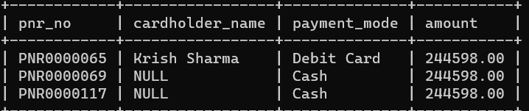

1. Select PRN_no, cardholder_name and payment mod who have min amount

Result:

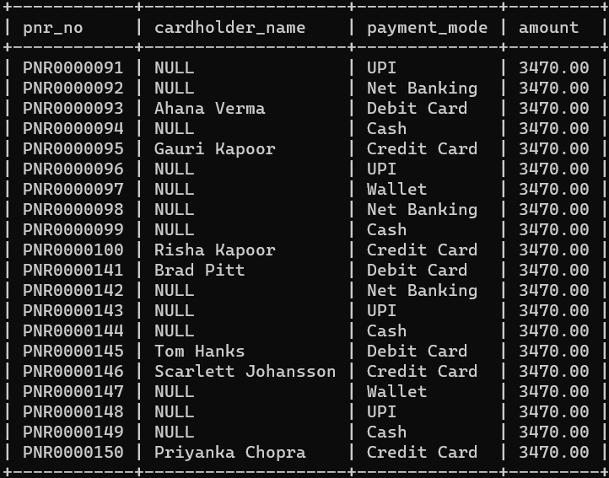

1. Select F_name from user and show where destination from Flight table

Result:

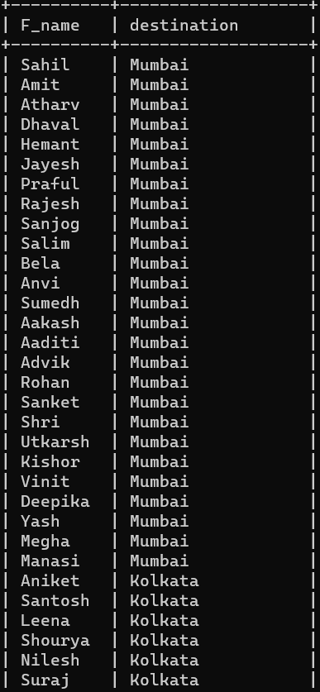

1. **JOINS:**
2. Inner Join between Aircraft and Aircraft_Employee tables based on Aircraft_id:

SELECT * FROM Aircraft INNER JOIN Aircraft_Employee ON Aircraft.Aircraft_id = Aircraft_Employee.Aircraft_id;

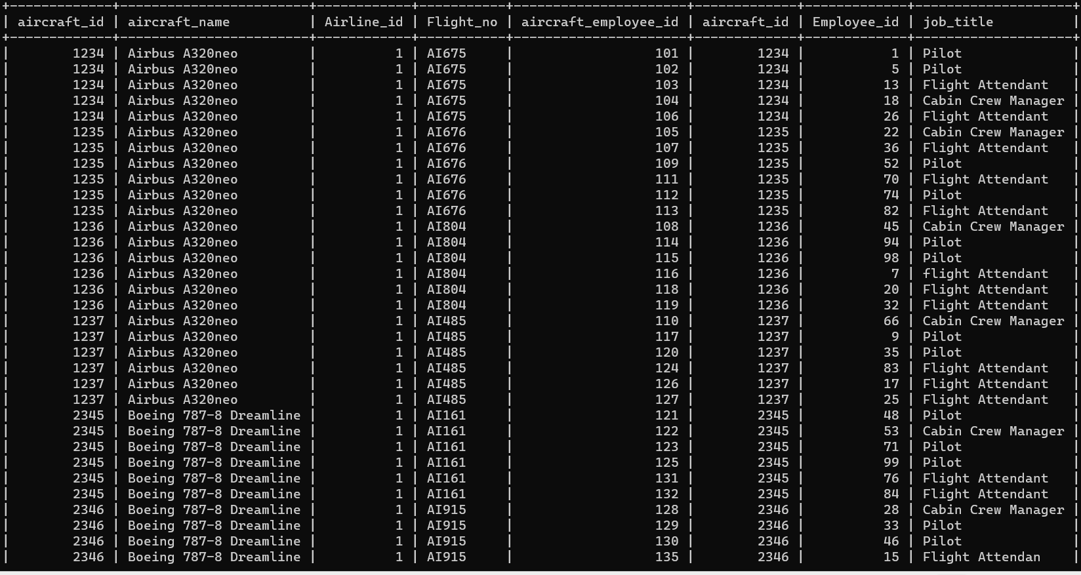

1. Airline table self join:

SELECT a1.airline_name AS airline1, a2.airline_name AS airline2 FROM Airline AS a1 INNER JOIN Airline AS a2 ON a1.country = a2.country WHERE a1.airline_id <> a2.airline_id;

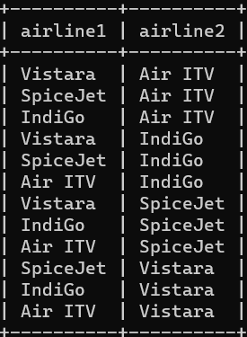 Result:

1. RIGHT JOIN between **User** and **boardingPass**

SELECT * FROM boardingPass RIGHT JOIN User ON boardingPass.boarding_pass_id = User.boarding_pass_id;

Result:

